

**GROUP ASSIGNMENT**

**TECHNOLOGY PARK MALAYSIA**

**CT106-3-2-SNA**

**SYSTEM AND NETWORK ADMINISTRATION**

**APU2F2502CS(CYB)**

**HAND OUT DATE: 9th MARCH 2025**

**HAND IN DATE: 27th MAY 2025**

**WEIGHTAGE:** **30%**

**LECTURER NAME: Mr. SHAHAB ALIZADEH / TS. DR. MANIMEGALAI A/P RAJENDERAN**

**GROUP NO.: LAB 11 - GROUP 17**

**INSTRUCTIONS TO CANDIDATES:**

1. **Submit your assignment at the administrative counter.**
2. **Students are advised to underpin their answers with the use of references (cited using the Harvard Name System of Referencing).**
3. **Late submission will be awarded zero (0) unless Extenuating Circumstances (EC) are upheld.**
4. **Cases of plagiarism will be penalized.**
5. **The assignment should be bound in an appropriate style (comb bound or stapled).**
6. **Where the assignment should be submitted in both hardcopy and softcopy, the softcopy of the written assignment and source code (where appropriate) should be on a CD in an envelope / CD cover and attached to the hardcopy.**
7. **You must obtain 50% overall to pass this module.**

|  |  |
| --- | --- |
| **Student ID** | **Student Name** |
| TP079000 | LIM HAO ZHEN |
| TP079795 | CHONG CHIA ZHI |
| TP080425 | VOON WEI SIANG |
| TP080482 | HO KUN YUN |
| TP081340 | LEE YI CHERN |

**Table of Contents**

1.0 Introduction 4

2.0 Network Configuration 5

2.1 Set up and change hostname on Server and Client 5

2.2 Set Static IP address on Server – Rocky 9

3.0 Network File System (NFS) Configuration 15

3.1 NFS Configuration on Rocky 15

3.2 NFS Configuration on Ubuntu 25

3.3 Testing NFS 28

3.3.1 Evidence 1 28

3.3.2 Evidence 2 30

3.4 Configure Permanent Mount Points on NFS Ubuntu 31

4.0 Apache Web Server 34

4.1 Install Apache Web Server on Rocky 34

4.2 Configuration Apache Web Server on Rocky 35

4.2.1 Create Website Directories 35

4.2.2 Create samples of Index.html pages 36

4.2.3 Enable Virtual Host and Modules 37

4.2.4 Add HTTP to Firewall 39

4.3 Configuration Apache Web Server on Ubuntu Client 40

4.4 Access the Website on Ubuntu Client 42

5.0 Certificate Authority (CA) 44

5.1 Install OpenSSL program 44

5.2 Configuration CA 45

5.2.1 Preparing Public Key Infrastructure Directory 45

5.2.2 Create Certificate Authority (CA) 45

5.2.3 Create Website’s CSR – Certificate Signing Request 47

5.2.4 Sign the CSR using CA 48

5.2.5 Configuration Virtual Hosts 49

5.2.6 Distribute Public Certificate of CA 52

5.2.7 Enable HTTPS Support in Apache 57

5.3 Testing HTTPS between Client and Server 59

5.4 Secure email between Client and Server 61

5.4.1 Configure Postfix 61

5.4.2 Configure Dovecot 63

5.4.3 Testing secure email between Client and Server 65

5.4.4 New Certificate for Thunderbird 72

6.0 Additional Service – Samba 73

6.1 Configure Samba 73

6.2 Test Service on Ubuntu 79

7.0 Conclusion 82

8.0 Reference 83

9.0 Workload Matrix 84

# 1.0 Introduction

The goal of this assignment is to build a secure and complete server-client network using virtualization technology. Our tests will use Rocky Linux on the server and Ubuntu Linux on the client, both running in the same Oracle VirtualBox environment. Our main goal is to accumulate experience in system administration, network settings, and installation of important services.

Furthermore, we will achieve essential tasks on the Rocky server by assigning a static IP address, configuring the FQDN and setting up NFS file sharing. In addition, we set up the Apache web server to allow clients to view websites within our network. Moreover, we applied Secure Sockets Layer (SSL) encryption certificates issued by Certificate Authority (CA) to make the environment more secure and enable Hypertext Transfer Protocol Secure (HTTPS) to keep all connexions safe. Plus, we have also set up and configured SAMBA on Rocky Linux to improve sharing files between different platforms. SAMBA allows Linux and Windows computers to easily share files and printers with each other. It is most helpful in situations with multiple operating systems and helps guarantee secure access to resources that are shared by users.

Lastly, we set up our Ubuntu client to work well with our Rocky Linux server, allowing us to mount folders using NFS and access web pages hosted on it. This assignment also will cover adding a new extra service that we had not learned in the previous lab tutorials. It helped us prepare and gave us a chance to learn new skills and apply what we had learned on the lab tutorials.

# 2.0 Network Configuration

## 2.1 Set up and change hostname on Server and Client

**Step 1:**

* Type hostname to check the current Rocky Server hostname.
* hostname

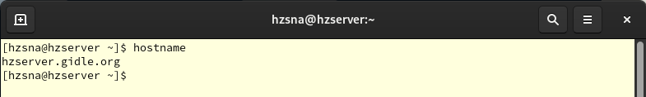



**Step 2:**

* Use below following command to edit our hostname.
* The file hostname at the /etc/hostname.
* sudo nano /etc/hostname





**Step 3:**

* Add or modify our FQDN.
* Here, we change to **grp17server.gidle.org**
* Close and save when done added or modified.

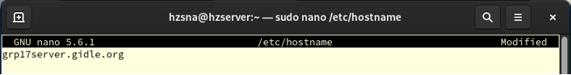



**Step 4:**

* Check the hostname file to see if is saved using below command.
* Make sure the hostname is same.
* cat /etc/hostname

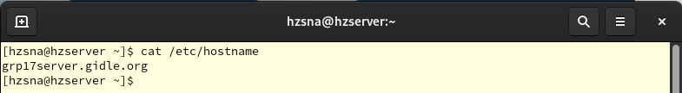



**Step 5:**

* To configure hosts file, using following command.
* This file is used to map hostnames to their respective IP addresses.
* It’s important to note that the system refers to this file first when resolving a server’s hostname.
* If a corresponding entry is found in /etc/hosts, the system will use that IP address directly, skipping any DNS queries.
* sudo nano /etc/hosts

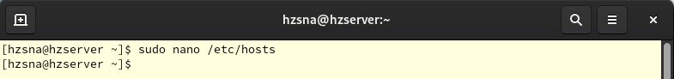



* Add your Rocky Server IP address along with its FQDN
* 192.168.200.4 shaserver.bungkus.org

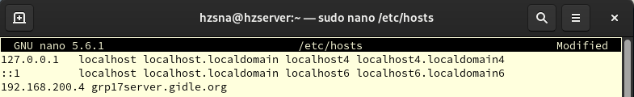



**Step 6:**

* We check the hosts configuration file.
* cat /etc/hosts

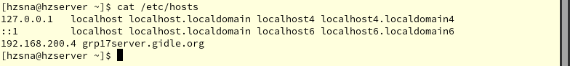



**Step 7:**

* Then we reboot the server.
* reboot

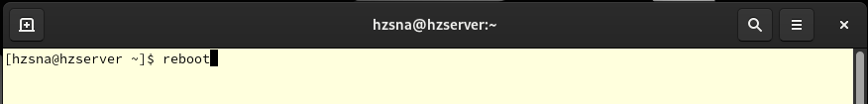



**Step 8:**

* We verify the Fully Qualified Domain Name (FQDN) by pinging the hostname instead of using its IP address.
* ping grp17server.gidle.org
* Use **Control + C** to break the ping.
* Make sure those packets are transmitted.

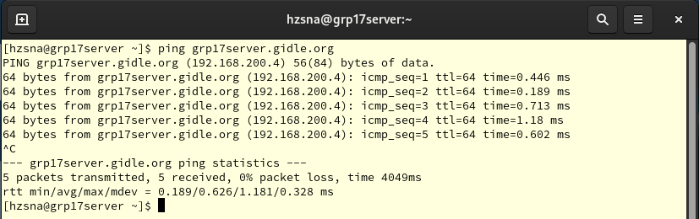



**Step 9:**

* Start the Ubuntu Client and open the Terminal.
* Type hostname to check the Ubuntu current hostname.
* hostname

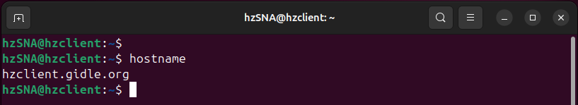



**Step 10:**

* Use below following command to configure hostname file.
* sudo nano /etc/hostname
* Same step as Rocky what we have done.
* Add or modify our new FQDN.





* Here, we change to **grp17client.gidle.org**
* Close and save when done added or modified.

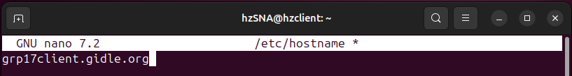



**Step 11:**

* Verify the Fully Qualified Domain Name (FQDN) by examining the hostname file.
* sudo cat /etc/hostname

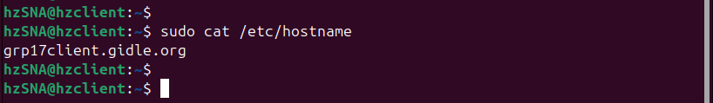



**Step 12:**

* Then we reboot.
* reboot





## 2.2 Set Static IP address on Server – Rocky

**Step 1:**

* We update & upgrade the system through the use of the DNF repository.
* sudo dnf update
* sudo dnf upgrade

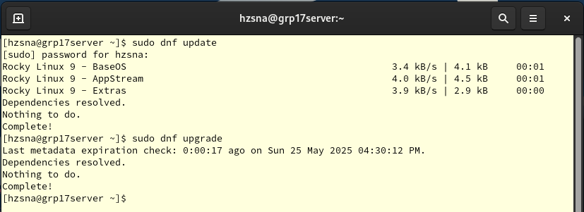



**Step 2:**

* Then reboot the system.
* reboot





**Step 3:**

* A static IP address is set up on the server, typically managed through **NetworkManager.**
* We verify whether **NetworkManager** is present, it generally comes pre-installed in Rocky Linux..
* sudo systemctl enable NetworkManager
* sudo systemctl start NetworkManager
* sudo systemctl status NetworkManager
* Make sure it is a**ctive (running)** and **enabled**.

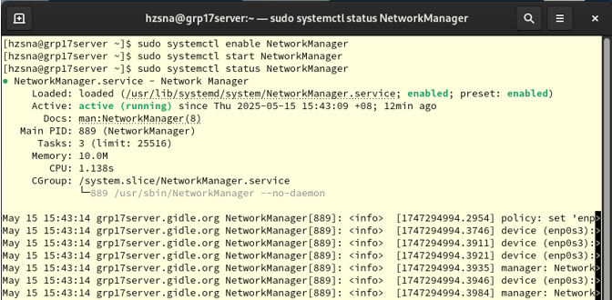



**Step 4:**

* We use **ifconfig** command to view the current IP address configuration.
* Here, IP address = **192.168.200.4** and Interface name = **enp0s3**
* ifconfig

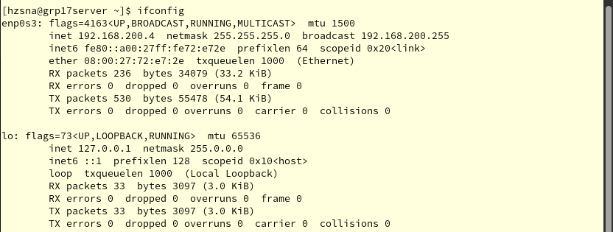



**Step 5:**

* Additional details about the system's network configuration can be obtained by using the following command.
* sudo nmcli general status
* sudo nmcli device status

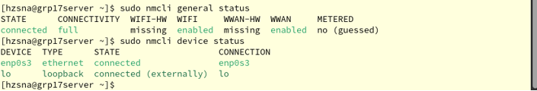



**Step 6:**

* We then determine the name of our active network connection, which allows us to modify it later to assign a static IP address.
* In this scenario, the connection is defined in the file **enp0s3.nmconnection,** which stores configuration settings for the network interface card (NIC) responsible for managing network and internet access.
* sudo ls -l /etc/NetworkManager/system-connections/

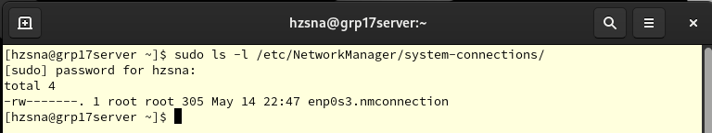



**Step 7:**

* Using nano, we open the previously identified connection file (enp0s3.nmconnection) to modify the network configuration settings.
* sudo nano /etc/NetworkManager/system-connections/enp0s3.nmconnection

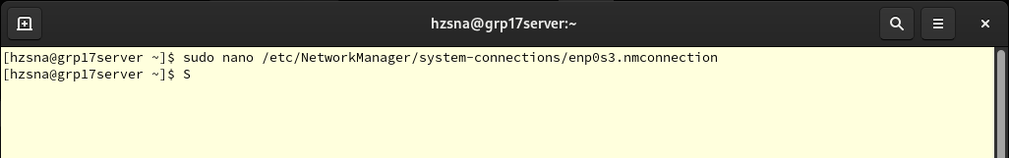



**Step 8:**

* We configure the static IP address, default gateway, and DNS server within the connection file.
* Modify and add the following lines below if any lines missing.
* **Static IP Address:** address1=192.168.200.4/24
* **Default Gateway/Route:** 192.168.200.1
* **DNS IP addresses:** 8.8.8.8;8.8.4.4
* **DNS server:** 192.168.200.4
* ignore-auto-dns=true
* method=manual

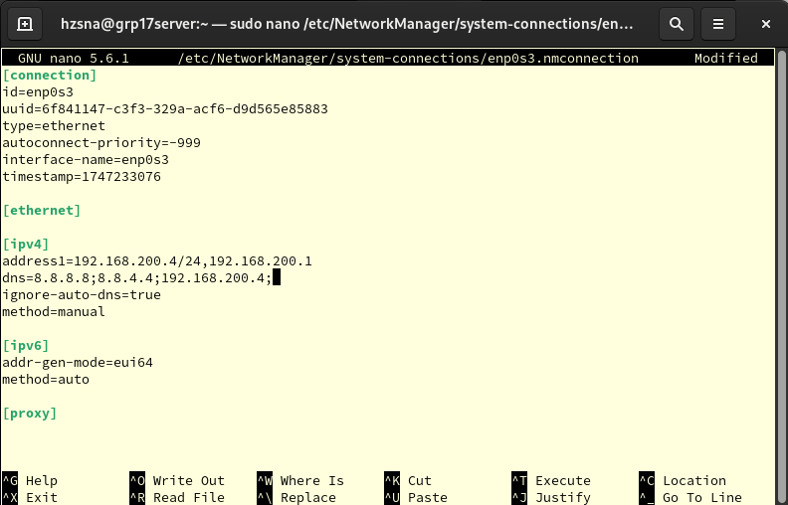



**Step 9:**

* After modifying the network settings, we restart the NetworkManager service to apply the changes.
* sudo systemctl restart NetworkManager
* sudo systemctl status NetworkManager

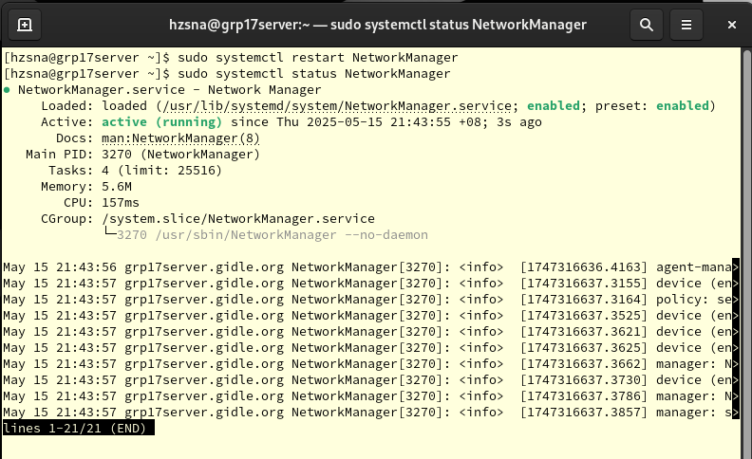



**Step 10:**

* We then test the configuration; if the changes do not take effect, a system reboot may be required.
* nmcli

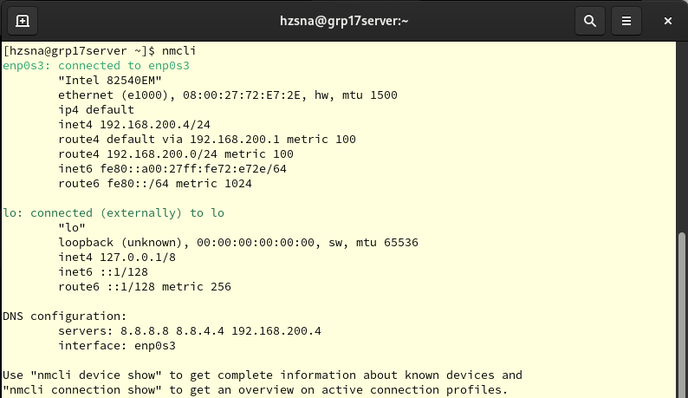



**Step 11:**

* We can also use other command to check other network settings.
* nmcli connection show
* nmcli connection show enp0s3

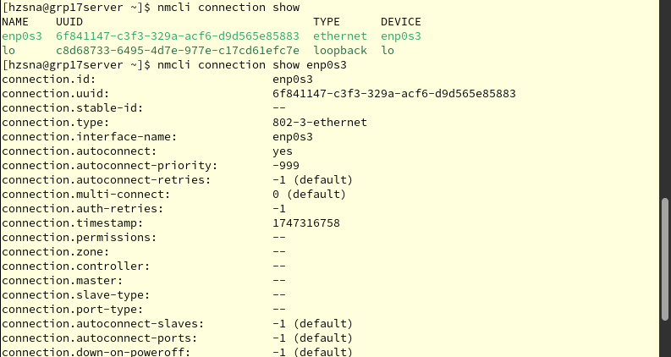



# 3.0 Network File System (NFS) Configuration

3.1 NFS Configuration on Rocky

**Step** **1:**

* First, we check the operating system we have installed using following command.
* cat /etc/os-release

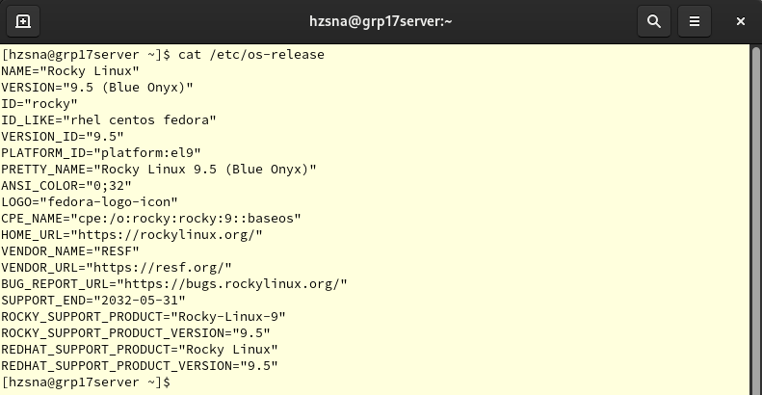



**Step 2:**

* We proceed to install the NFS server software.
* sudo dnf install nfs-utils

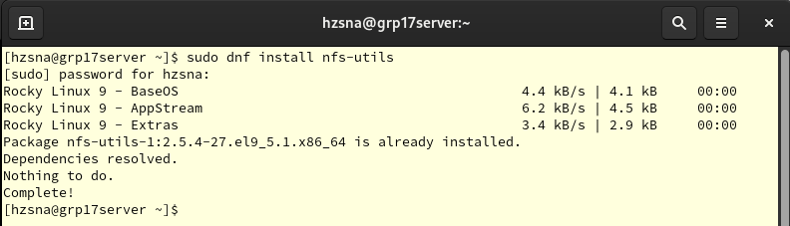



**Step 3:**

* The NFS server must be enabled to start automatically.
* sudo systemctl enable nfs-server --now





**Step 4:**

* We start the NFS service and verify its status.
* sudo systemctl start nfs-server
* sudo systemctl status nfs-server

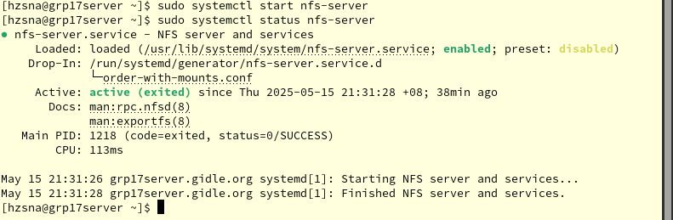



**Step 5:**

* The command below is used to confirm the installed version of NFS.
* By default, NFS versions 3 and 4 are enabled, while version 2 is disabled as it is outdated.
* sudo cat /proc/fs/nfsd/versions





**Step 6:**

* We create a directory on the server to be shared with our Ubuntu client.
* sudo mkdir /var/nfs/grpassignment -p

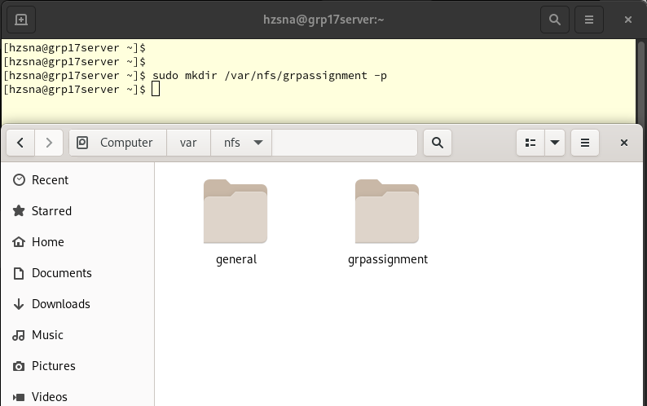



**Explanation of the above command:**

* **-p**: When the -p flag is used with mkdir, it ensures that any required parent directories are also created if they do not already exist.

**Step 7:**

* Now, we then inspect the permissions and ownership of the newly created directory.
* sudo ls -dl /var/nfs/grpassignment

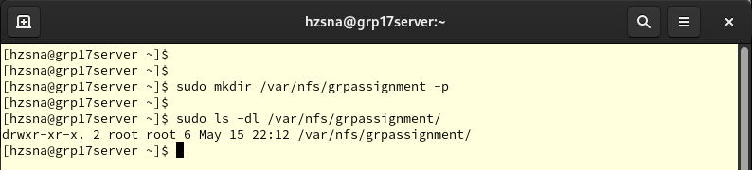



Root is the owner with full permission setting

**Step 8:**

* Next, we change the directory’s ownership to the nobody user and group, allowing client access.
* sudo chown nobody:nobody /var/nfs/grpassignment/





**Explanation of the above command:**

* **chown:** This command modifies the ownership of a file or directory.
* **nobody:nobody:** This designates both the user and group ownership as nobody.

**Step 9:**

* We must edit the exports file to define shared directories.
* This file specifies which server directories can be shared and the access permissions for clients.
* sudo nano /etc/exports





**Step 10:**

* Add the following line to the file
* /var/nfs/grpassignment 192.168.200.80(rw,sync,no_subtree_check)

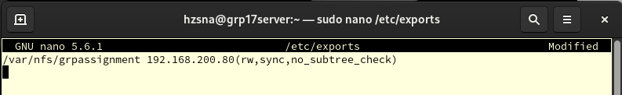



Make sure you are using your new IP address of Ubuntu Client

**Explanation of the above command:**

* **Path - /var/nfs/grpassignment:** This denotes the directory being shared; clients with permission can access its contents.
* **Client - 192.168.200.80**: Specifies the IP address of the Ubuntu client that is authorized to mount the NFS share. Only this client can access it.
* **Permissions – (rw,sync,no_subtree_check):**  These define the client’s access level for the share.
* **rw:** Grants read and write permissions, allowing file modifications and creation.
* **sync:** Ensures that any write actions by the client are immediately written to the server’s disk.
* **no_subtree_check:** Disables subtree checking, enhancing reliability by preventing errors when files are renamed on the host while open on the client. Disabling it improves the reliability of NFS.

**Step 11:**

* Next, we now manage and export the NFS shares defined in the /etc/exports file.
* sudo exportfs -arv

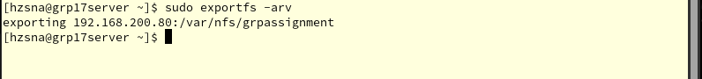



**Explanation of the above command:**

* **sudo:** This indicates that administrative privileges are required. You’ll need to authenticate as a privileged user.
* **exportfs:** This command manages NFS exports.
* **-a:**  Exports all entries listed in the /etc/exports file.
* **-r:** Re-exports any currently shared directories, useful after modifying the exports file.
* **-v**: Enables verbose mode to display detailed information about each export.

**Step 12:**

* Here, we use the following command to view all exported directories and their options, including defaults.
* sudo exportfs -s

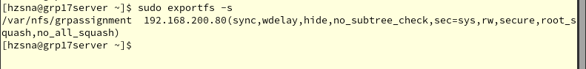



**Explanation of the above command:**

* **-s:** This tells exportfs to display the status of the currently exported file systems.

**Step 13:**

* Then, we then **restart** the NFS server to apply the changes.
* sudo systemctl enable --now rpcbind nfs-server
* sudo systemctl restart nfs-server
* sudo systremctl status nfs-server

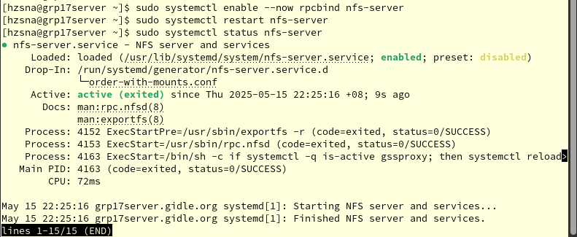



**Explanation of the above command:**

* **rpcbind:** This service supports port mapping for NFS. It will help NFS services to register with portmapper, allowing clients to locate NFS servers on the network.

**Step 14:**

* To allow NFS services through the firewall, we add the required services using the command below.
* sudo firewall-cmd --add-service={nfs,nfs3,rpc-bind,mountd} --permanent
* sudo firewall-cmd --reload
* sudo firewall-cmd --zone=public --list-all

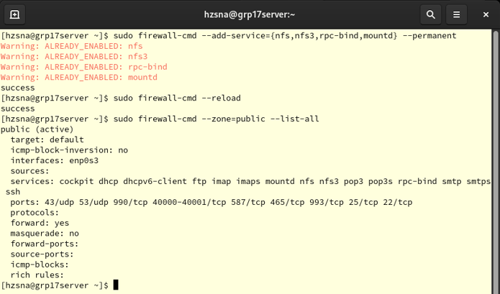

All the services and ports allowed by firewall so far



**Step 15:**

* To ensure everything is applied correctly, we restart the NFS services once more.
* After restart, we will the status and make sure it is **active (running).**
* sudo systemctl daemon-reload
* sudo systemctl restart nfs-server
* sudo systemctl status nfs-server

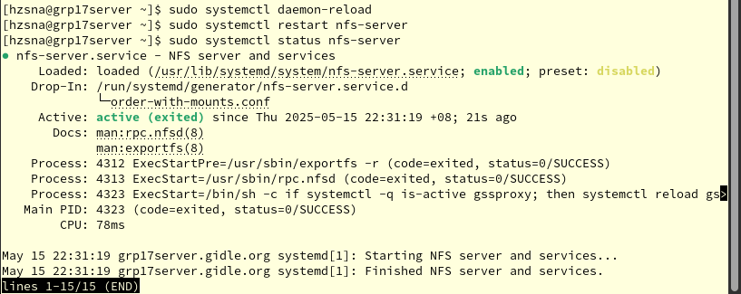



**Explanation of the above command:**

* **sudo systemctl daemon-reload:** This reloads systemd service configurations, so any recent changes take effect.

**Step 16:**

* Now, we create some files in our shared directory.
* cd /var/nfs/grpassignment
* sudo touch TestDoc{1..4}.txt
* The following command is used to list all existing files.
* ls -l

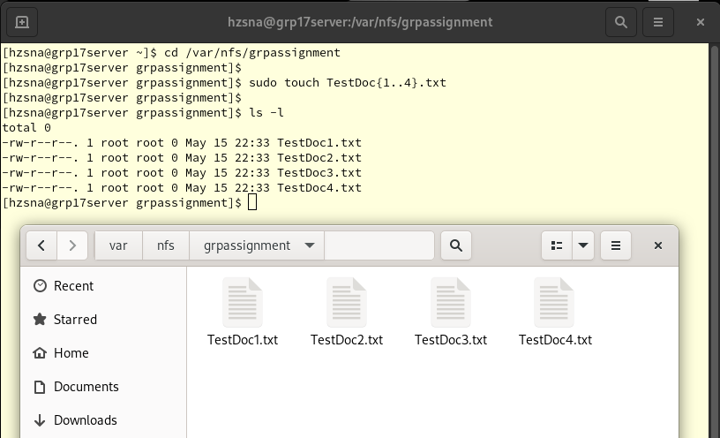



## 3.2 NFS Configuration on Ubuntu

**Step 1:**

* We install the NFS client software on the Ubuntu machine.
* sudo apt install nfs-kernel-server
* sudo apt install nfs-common

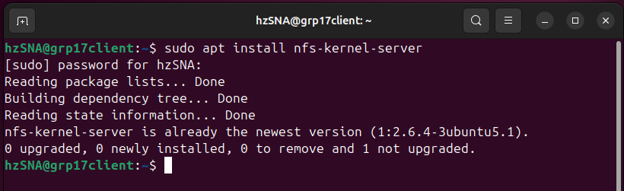







**Step 2:**

* To mount the server’s shared directory on the client, we create a local directory on the Ubuntu client.
* sudo mkdir /nfs/Shared_grpassignment -p

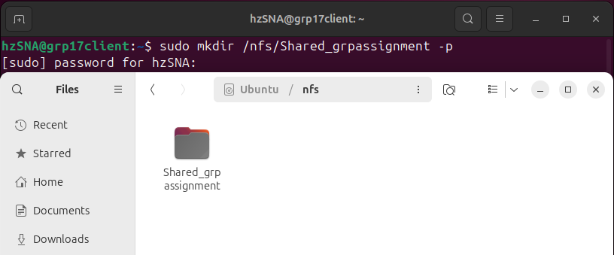



**Step 3:**

* Next, we mount the remote server directory (NFS share) to the newly created local directory.
* sudo mount 192.168.200.4:/var/nfs/grpassignment /nfs/Shared_grpassignment
* Make sure the directory is correct.

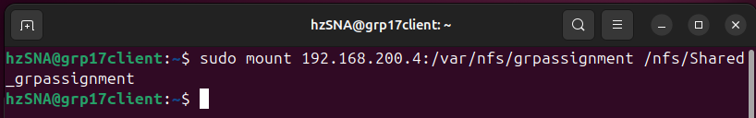



**Explanation of the above command:**

* **mount:** This used for mounting a filesystem. Here, it’s used to mount a remote NFS share.
* **192.168.200.4: /var/nfs/grpassignment:** This specifies the location of the remote directory on the server. 192.168.200.4 is the IP address of the server, and /var/nfs/grpassignment is the path to the directory,
* **/nfs/Shared_grpassignment:** This specifies the location where want to mount the remote directory on the client.

**Step 4:**

* We verify that the shared directory is visible and accessible from the client.
* df -h

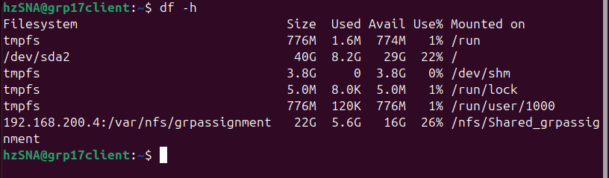



**Step 5:**

* The /var/nfs/grpassignment directory can be mounted to the local mount point /nfs/Shared_grpassignment.
* Once mounted, all files within the grpassignment directory should be accessible from the client side.
* In order words, we can now access files from the Rocky server on the Ubuntu client through the Shared_grpassignment mount.
* ls -l /nfs/Shared_grpassignment

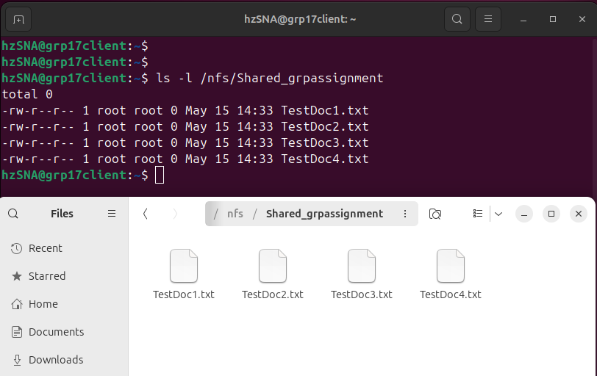



These files are at our Rocky Server but now we have mounted to this Shared_grpassignnent at Ubuntu. So, we can access all the files from server.



## 3.3 Testing NFS

### 3.3.1 Evidence 1

**Step 1:**

* For testing, we added a file named **testing.txt** in the Ubuntu client’s shared directory.
* sudo touch /nfs/Shared_grpassignment/testing.txt
* Make sure that the file is created and list it by using below command.
* ls -l /nfs/Shared_grpassignment

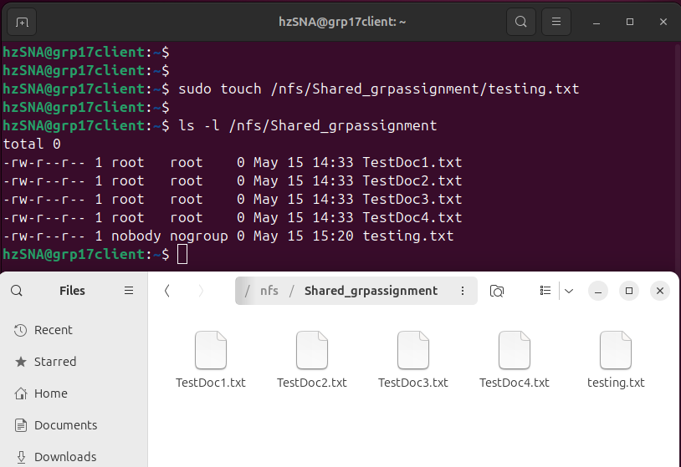



**Step 2:**

* Back to our **Rocky Server,** we use the command line interface to verify that the file is also visible.
* ls -l /var/nfs/grpassignment
* If yes, our NFS configuration is successful.

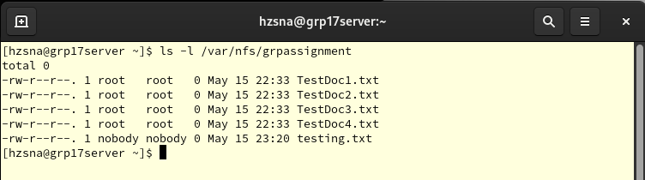



### 3.3.2 Evidence 2

**Step 1:**

* We create a directory named **Malaysia** on the server and verify its visibility on the client.
* cd /var/nfs/grpassignment
* mkdir Malaysia
* ls -l

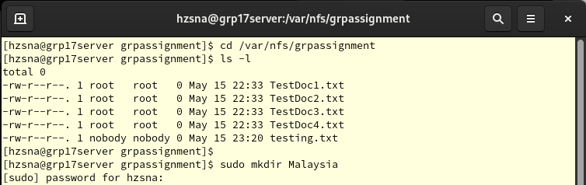



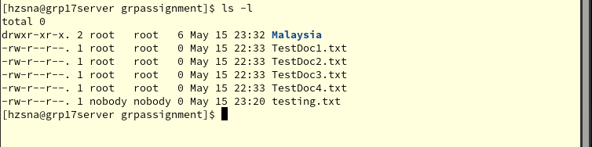



**Step 2:**

* Next, we return to the **Ubuntu client** and check the newly created directory using CLI.
* ls -l /nfs/Shared_grpassignment

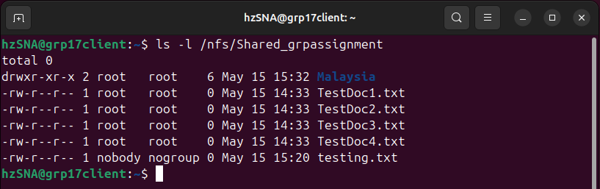



We can see the directory we created at server side is existing at our Ubuntu client as well.



## 3.4 Configure Permanent Mount Points on NFS Ubuntu

**Step 1:**

* Now, we need to mount persistently instead of temporarily mounts.
* To do this, we add an entry to the fstab file using the command below
* sudo nano /etc/fstab

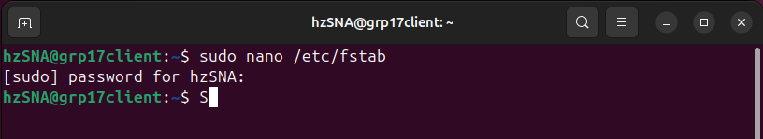



**Step 2:**

* Next, add the following lines to the**fstab** file to ensure the server’s shared directory mounts automatically.
* Make sure that no typing error for following lines below.
* 192.168.200.4:/var/nfs/grpassignment *[tab]*/nfs/Shared_grpassignment nfs auto,nofail,noatime,nolock,intr,tcp,actimeo=1800 0 0
* Please note that *[tab]* is for your action. No need to type it.

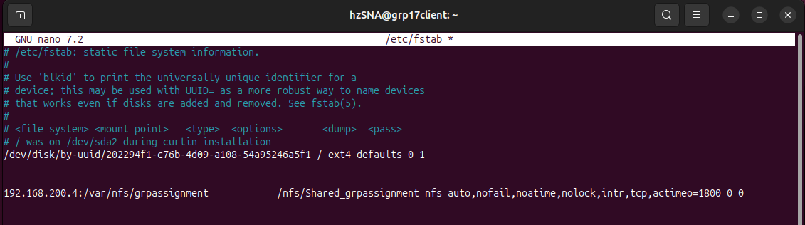



**Explanation of the above command:**

* **192.168.200.4:/var/nfs/grpassignment:** This indicates the NFS server’s IP and the shared directory.
* **/nfs/Shared_grpassignment:** This is the client-side directory where the shared content will be mounted.
* **nfs:** Specifies that this is an NFS mount.
* **auto:** Automatically mounts the directory at system startup.
* **nofail:** Prevents boot failure if the NFS server is unavailable; the system will retry later.
* **noatime:** Enhances performance by not updating access times on files.
* **nolock:** Disables file locking, which may be required by some applications.
* **intr:** This allows NFS operations to be interrupted if necessary
* **tcp:** Uses the TCP protocol, offering more reliable communication than UDP.
* **actimeo=1800:** Sets the attribute cache timeout to 1800 seconds (30 minutes), helping with reconnect attempts.
* **0 0:** These values prevent automatic checks or backups on the mount.

**Step 3:**

* Check the **/etc/fstab** file for correct syntax.
* sudo mount -a





**Step 4:**

* Then, we reboot the system.
* reboot

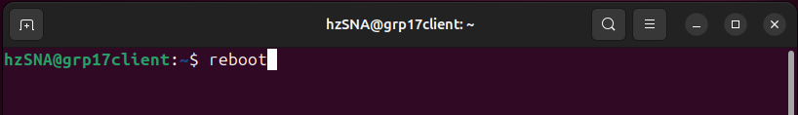



**Step 5:**

* After reboot, confirm that the shared directory is still accessible.
* If yes, we successfully mount persistently.
* ls -l /nfs/Shared_grpassignment

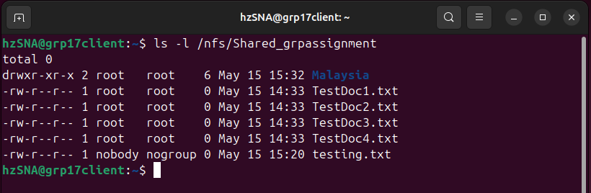



# 4.0 Apache Web Server

## **4.1 Install Apache Web Server on Rocky**

**Step 1:**

* First, we install Apache Web Server.
* sudo dnf install httpd -y

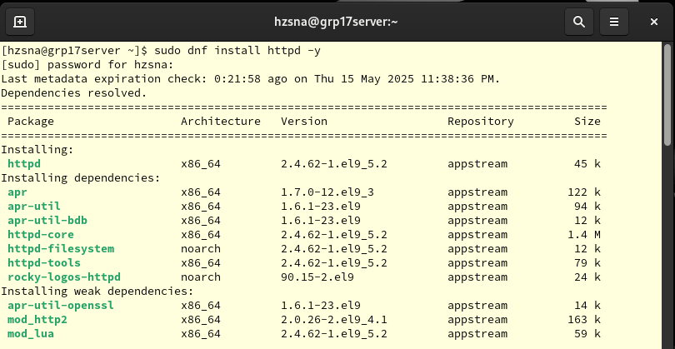



**Step 2:**

* Next, we enable the Apache server.
* sudo systemctl enable --now httpd

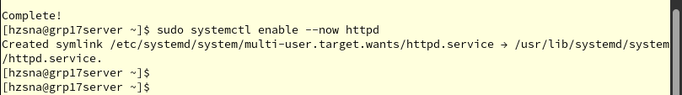



## 4.2 Configuration Apache Web Server on Rocky

### 4.2.1 Create Website Directories

**Step 1:**

* Firstly, we create a directory for our website as we can host the files using Apache Server.
* Here, we create directories for two websites: **site1.grp17.local** and **site2.grp17.local**.
* sudo mkdir -p /var/www/site1.grp17.local/html
* sudo mkdir -p /var/www/site2.grp17.local/html

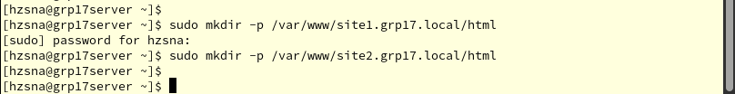



**Step 2:**

* Next, we give the Apache web server full ownership of the site directories, so it can read, serve and write content.
* sudo chown -R apache:apache /var/www/site1.grp17.local
* sudo chown -R apache:apache /var/www/site2.grp17.local





**Explanation of the above command:**

* **-R:** This is applying the change to all files and subdirectories inside the target folder, not just the top-level folder.
* **apahce:apache:** This means we set both the **owner** and **group** to Apache.

### 4.2.2 Create samples of Index.html pages

**Step 1:**

* Now, we create a basic **HTML file** for each site that displays the content in a heading when visited.
* echo “<h1>Welcome to site 1</h1>” | sudo tee /var/www/site1.grp17.local/html/index.html
* echo “<h1>Welcome to site 2</h1>” | sudo tee /var/www/site2.grp17.local/html/index.html

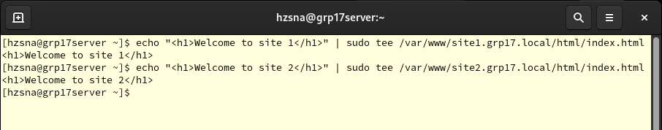



**Explanation of the above command:**

* **echo “<h1>Welcome to site 1/2</h1>”:** This will print the line **Welcome to site 1** to the terminal.
* **| :** Takes the output of the **echo** command and sends it to the next command on the right.
* **tee:** This writes input to a file.

### 4.2.3 Enable Virtual Host and Modules

**Step 1:**

* Here, we are using below commands to open and create configuration files for **Apache** **Virtual Hosts**.
* It is allowing Apache to server different content for **site1.grp17.local** and **site2.grp17.local.**
* sudo nano /etc/httpd/conf.d/site1.conf





**Step 2:**

* When the file is created, we add the lines below in the file.
* This file is going to tells Apache that if someone visits the two websites, it will serve files from these configuration files.
* <VirtualHost *:80>

Server Name site1.grp17.local

DocumentRoot /var/www/site1.grp17.local/html

</VirtualHost>

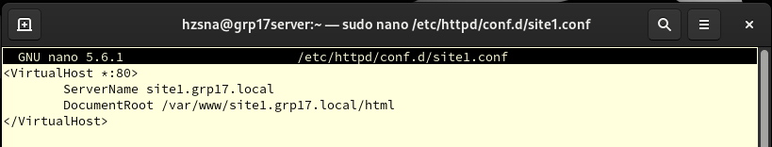



**Explanation of the above command:**

* **<VirtualHost *: 80>:** This lets Apache to listen on **port 80** for any **IP address (*)**.
* **ServerName:** Defines the domain name for this virtual host.
* **DocumentRoot:** This tells Apache where to look for the website’s files **(index.html)**
* **</VirtualHosts>:** Close the virtual host block.

**Step 3:**

* After done for the site 1, we do the same step for **site 2.**
* sudo nano /etc/httpd/conf.d/site2.conf

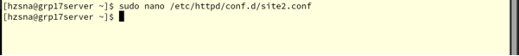



* <VirtualHost *:80>

Server Name site2.grp.local

DocumentRoot /var/www/site1.grp17.local/html

</VirtualHost>

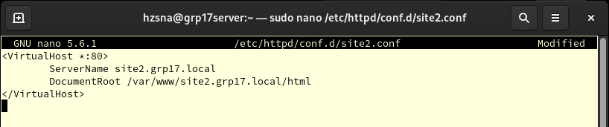



### 4.2.4 Add HTTP to Firewall

**Step 1:**

* Now, we are going to add the **service of http** **(port 80)** permanently in the firewall.
* sudo firewall-cmd --permanent --add-service=http
* sudo firewall-cmd --reload

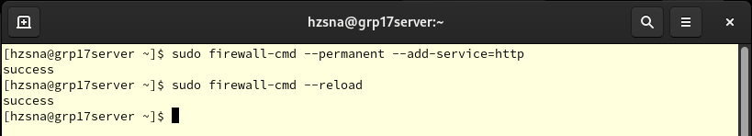



**Step 2:**

* Next, we **restart** the httpd and view the **status** of httpd since we made some configuration in httpd.
* sudo systemctl restart httpd
* sudo systemctl status httpd
* Make sure the status of the httpd is **active (running).**

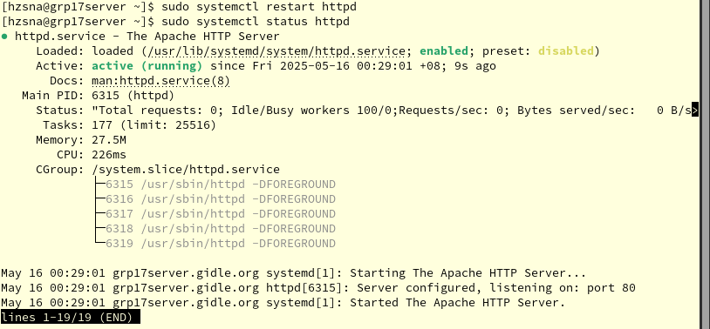



## 4.3 Configuration Apache Web Server on Ubuntu Client

**Step 1:**

* We go to Ubuntu Client side and open the **hosts** file do configuration.
* sudo nano /etc/hosts

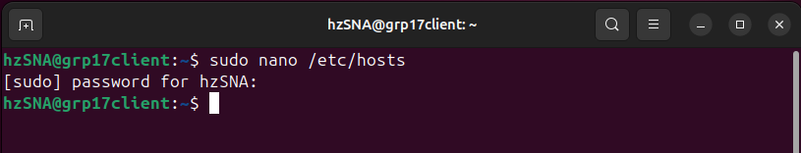



**Step 2:**

* We modify or add the lines below to ensure that the **domain names** are correctly resolved to **server’s IP address** for local access without relying on DNS.
* 192.168.200.4 site1.grp17.local site2.grp17.local

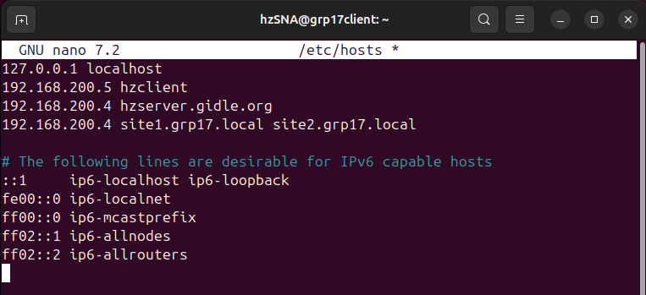



**Step 3:**

* Next, we install **curl** using following command for testing or sending web requests, without asking for confirmation.
* sudo apt install curl -y

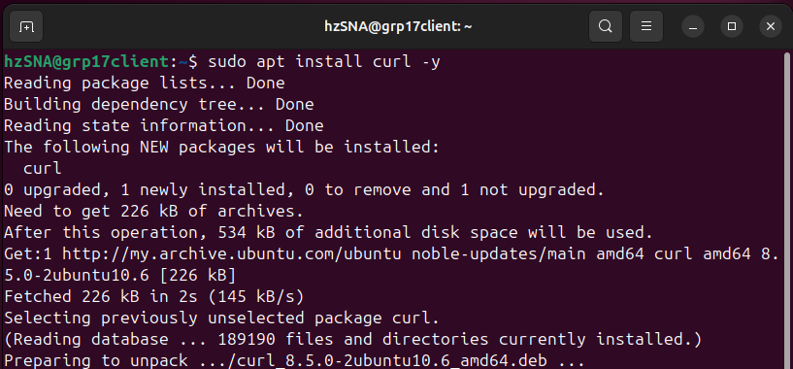



**Step 4:**

* When done installed, we are now testing the virtual hosts using **curl.**
* Make sure that the output is correctly.
* curl http://site1.grp17.local
* curl http://site2.grp17.local

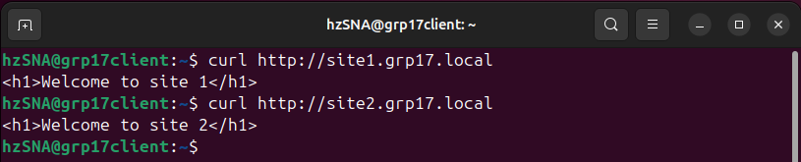



## 4.4 Access the Website on Ubuntu Client

**Step 1:**

* Firstly, we open the **FireFox** in our Ubuntu Client.





**Step 2:**

* In the search box, we enter the website name to proceed to the website.
* http://site1.grp17.local
* http://site2.grp17.local

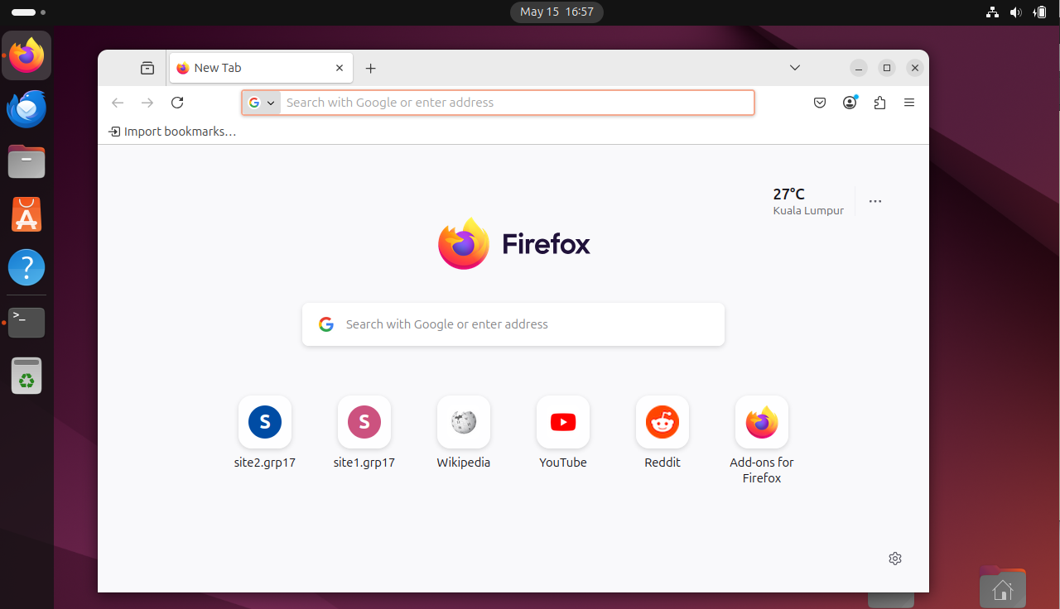

Enter the website here for site 1 & site 2



**Step 3:**

* It will prompt out the site for the site1.grp17.local.
* It will see the website 1 is **not secure** for now.

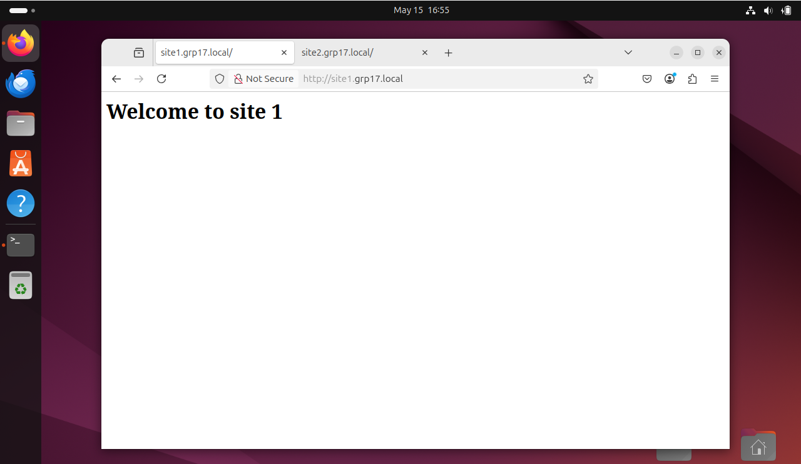



The site is not secure for now



**Step 4:**

* It will prompt out the site for the site2.grp17.local.
* It will see the website 2 is **not secure** for now.

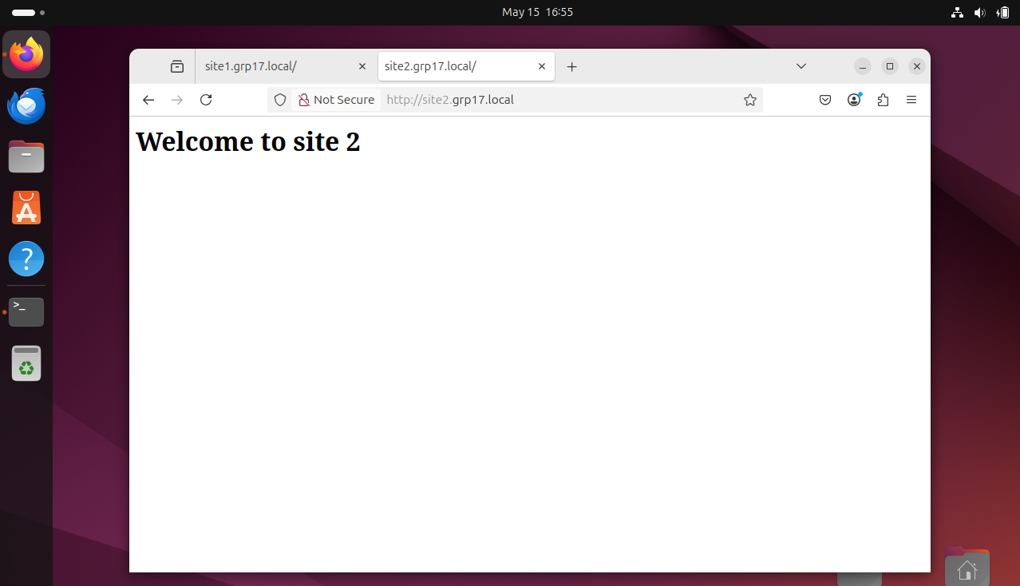

The site is not secure for now



# 5.0 Certificate Authority (CA)

## 5.1 Install OpenSSL program

**Step 1:**

* Now, for enabling **HTTPS support in Apache** and **generate SSL certificates**, we need to install the **mod_ssl** and **openssl** using following command.
* sudo dnf install mod_ssl openssl -y

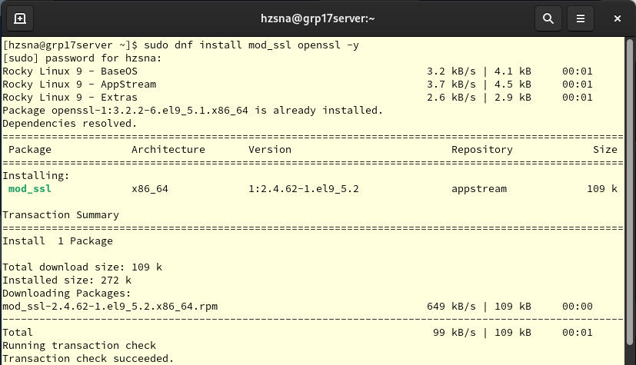



## 5.2 Configuration CA

### 5.2.1 Preparing Public Key Infrastructure Directory

**Step 1:**

* Next, we create a new directory at **/etc/pki/tls/grp17CA** to store my group’s CA-related files.
* sudo mkdir -p /etc/pki/tls/grp17CA



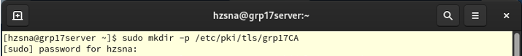



### 5.2.2 Create Certificate Authority (CA)

**Step1:**

* Then using the following command to create a secure 2048-bit RSA private key file for the Certificate Authority (CA).
* sudo openssl genrsa -out /etc/pki/tls/grp17CA.key.pem 2048
* Make sure there are not any typing error while typing the command above.





**Explanation of the above command:**

* **sudo:** This is used to run the command with administrative privileges as generating certificates often requires writing to system directories.
* **openssl req:** This is the core command from the OpenSSL library used to generating keys and certificates.
* **genrsa:** This is the OpenSSL subcommand that generates an RSA private key.
* **-out /etc/pki/tls/grp17CA.key.pem:** It is specifying the output file path where the generated RSA private key will be saved.
* **2048:** The key size in bits, means here generating a 2048-bit RSA key. Which is considered secure for most purposes.

**Step 2:**

* Here, creating a new **self-signed certificate** for the CA using existing private key that we created at the step 1.
* This certificate will be valid for 365 days (1 year) and use SHA-256 for secure signing.
* sudo openssl -req -x509 -new -key /etc/pki/tls/grp17CA/grp17CA.key.pem -out /etc/pki/tls/grp17CA/grp17CA.cert.pem -days 365 -sha256

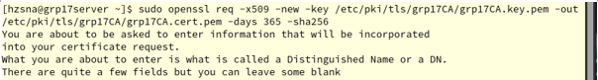



* Enter a dummy organization detail, can assume our organization is in Malaysia (MY):
* Here, the email address format here using is user@hostname.

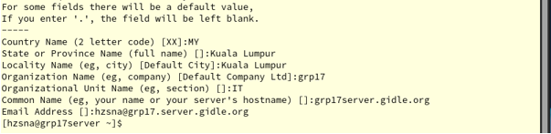



**Explanation of the above command:**

* **openssl req:** This is the core command from the OpenSSL library used to create certificate signing requests (CSR) or self-signed certificates.
* **-x509:** This option tells OpenSSL to generate a self-signed certificate instead of a certificate signing request.
* **-new:** Indicates that creating a new certificate request or certificate, when used with

**-**x509.

* **-key /etc/pki/tls/grp17CA/grp17CA.key.pem:** Uses the private key that generated earlier to sign the certificate.
* **-out /etc/pki/tls/grp17CA/grp17CA.cert.pem:** Here specifies the output path for the certificate.
* **-days 365:** This option specifies the validity period of the self-signed certificate. Here, it's set to 365 days (one year).
* **-sha:** This option uses the SHA-256 hashing algorithm, which is a strong and modern hash function of signing the certificate.

### 5.2.3 Create Website’s CSR – Certificate Signing Request

**Step 1:**

* In this step, we generate a **new 2048-bit RSA private key** for a **website or server**
* Please note that this is not the CA’s key, this is for a specify **site/service** that will later receive a signed certificate.
* sudo openssl genrsa -out /etc/pki/tls/grp17CA/grp17site.key.pem 2048
* We also creating a **Certificate Signing Request (CSR)** using the private key that generated.
* sudo openssl req -new -key /etc/pki/tls/grp17CA/grp17site.key.pem -out /etc/pki/tls/grp17CA/grp17site.csr.pem

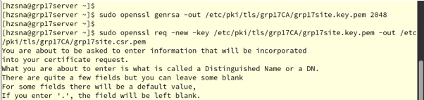



**Step 2:**

* Here, we are also needed to enter a dummy organization detail, can assume our organization is in Malaysia (MY):
* We need to set a challenge password and optional company name at this step.

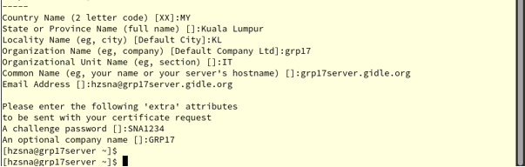



### 5.2.4 Sign the CSR using CA

**Step 1:**

* Now, we issue a signed certificate for the website or server using own CA. This makes the **grp17site.cert.pem** a trusted certificate, as long as our CA is trusted.
* After that, we will see the output **Certificate request self-signature ok.**
* sudo openssl x509 -req -in /etc/pki/tls/grp17CA/grp17site.csr.pem -CA /etc/pki/tls/grp17CA/grp17CA.cert.pem -CAkey /etc/pki/tls/grp17CA/grp17CA.key.pem -CAcreateserial -out /etc/pki/tls/grp17CA/grp17site.cert.pem -days 365 -sha256
* Make sure that don’t have any typing error.

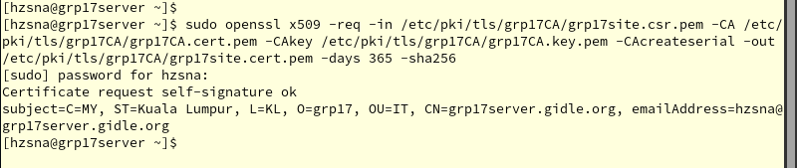



**Explanation of the above command:**

* **openssl x509 req:** This is processing a certificate request (CSR) to generate an actual x.509 certificate.
* **-in /etc/pki/tls/grp17CA/grp17site.csr.pem:** This input is the site’s certificate request.
* **-CA /etc/pki/tls/grp17CA/grp17CA.cert.pem:** Use this CA certificate to sign the request.
* **-CAkey /etc/pki/tls/grp17CA/grp17CA.key.pem:** Use this CA private key to perform the signing.
* **-CAcreateserial:** Automatically create a serial number file for the CA, it is used for tracking issued certs.
* **-out /etc/pki/tls/grp17CA/grp17site.cert.pem:** This tells OpenSSL where to save the result. Here, we save the signed certificate file in the path above.
* **-days 365:** This option specifies the validity period of the self-signed certificate. Here, it's set to 365 days (one year).
* **-sha:** This option uses the SHA-256 hashing algorithm, which is a strong and modern hash function of signing the certificate.

### 5.2.5 Configuration Virtual Hosts

**Step 1:**

* Here, we are using below commands to open and create configuration files for **Apache** **Virtual Hosts**.
* sudo nano /etc/httpd/conf.d/site1.conf





**Step 2:**

* In this step, we modify and add all lines below in the configuration files for **Apache** **Virtual Hosts**.
* We set up the Apache Web Server to serve the website securely using **HTPPS** on **port 443.**
* Also, it configures **SSL/TLS** for our site using the certificate created and signed with our CA.
* <VirtualHost *:443>

Server Name site1.grp17.local

DocumentRoot /var/www/site1.grp17.local/html

SSLEngine on

SSLCertificateFile /etc/pki/tls/grp17CA/grp17site.cert.pem

SSLCertificateKeyFile /etc/pki/tls/grp17CA/grp17site.key.pem

SSLCACertificateFile /etc/pki/tls/grp17CA/grp17CA.cert.pem

<Directory /var/www/site1.grp17.local/html>

AllowOverride All

Require all granted

</Directory>

</VirtualHost>

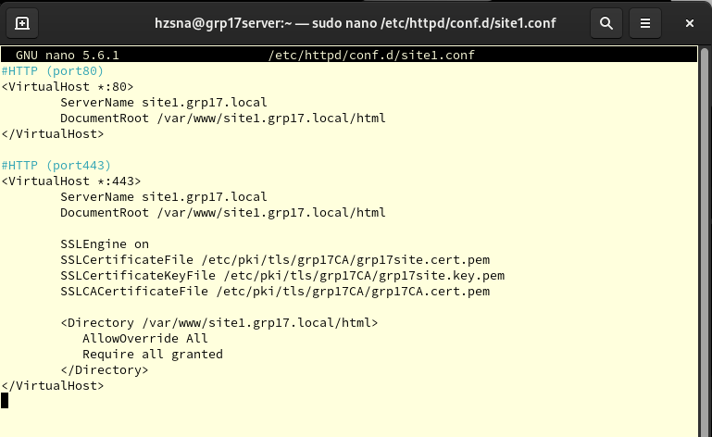



**Explanation of the above command:**

* **<VirtualHost *:443>:** This tells Apache listen on the port 443 (HTTPS) for any IP address (*).
* **ServerName:** Defines the domain name for this virtual host.
* **DocumentRoot:** This tells Apache where to look for the website’s files **(index.html)**
* **SSLEngine on:** This option enables SSL/TLS encryption for this site. It must be on for HTTPS.
* **SSLCertificateKeyFile /etc/pki/tls/grp17CA/grp17site.key.pem:** This is the site’s private key. It used for decrypting traffic.
* **SSLCACertificateFile /etc/pki/tls/grp17CA/grp17CA.cert.pem:**  This is the CA’s certificate. It used to validate that the site’s certificate is legitimate.
* **AllowOverride All:** This option is giving the permission. It allows **.htaccess** files to override settings.
* **Require all granted:** This option is giving the permission. It gives access to all users without any restrictions.
* **</VirtualHosts>:** Close the virtual host block.

**Step 3:**

* After done for the site 1, we do the same step for **site 2.**
* sudo nano /etc/httpd/conf.d/site2.conf





**Step 4:**

* <VirtualHost *:443>

Server Name site2.grp17.local

DocumentRoot /var/www/site1.grp17.local/html

SSLEngine on

SSLCertificateFile /etc/pki/tls/grp17CA/grp17site.cert.pem

SSLCertificateKeyFile /etc/pki/tls/grp17CA/grp17site.key.pem

SSLCACertificateFile /etc/pki/tls/grp17CA/grp17CA.cert.pem

<Directory /var/www/site2.grp17.local/html>

AllowOverride All

Require all granted

</Directory>

</VirtualHost>

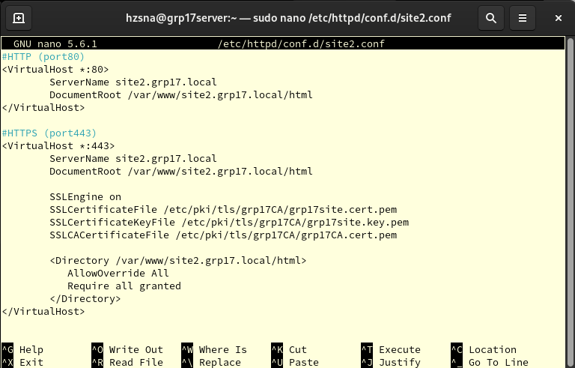



### 5.2.6 Distribute Public Certificate of CA

**Step 1:**

* For now, we are going to distribute the Public Certificate of CA to Ubuntu Client side.
* We need to modify or add the lines below in the **/etc/hosts** file.
* sudo nano /etc/hosts





* Make sure the following lines is added inside this file.
* 192.168.200.80 grp17client.gidle.org

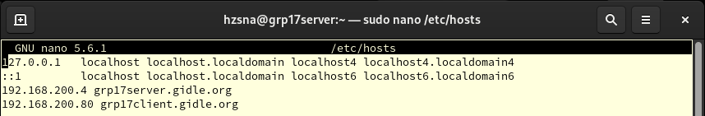



**Step 2:**

* We copy the CA certificate to Ubuntu Client using **scp**.
* Make sure that path of the certificate is correct.
* Check the hostname in Ubuntu to avoid any typing errors. **(grp17client.gidle.org)**
* scp /etc/pki/tls/grp17CA/grp17CA.cert.pem hzSNA@grp17client.gidle.org:/home/hzSNA

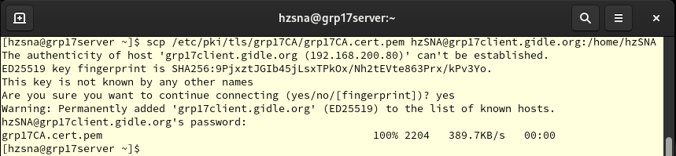



**Step 3:**

* We go back to Ubuntu side.
* We need to copy the CA cert to system CA directory. Here, we rename the copied cert file to **.crt** as required by Ubuntu’s trust store.
* sudo cp ~/grp17CA.cert.pem /usr/local/share/ca-certificates/grp17CA.crt
* Next, we update the trust store using following command.
* Make sure that the output that you see is **1 added**.
* sudo update-ca-certificates

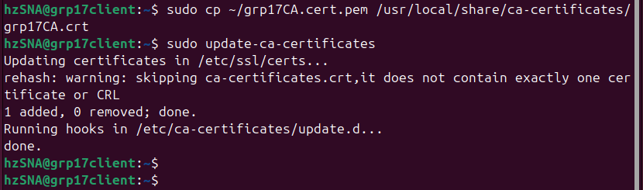



**Step 4:**

* We open the **FireFox** in our Ubuntu Client.
* Next, we click the **Hamburger Menu button** at the top-right corner of the main page and proceed to the **Settings**.

**1**

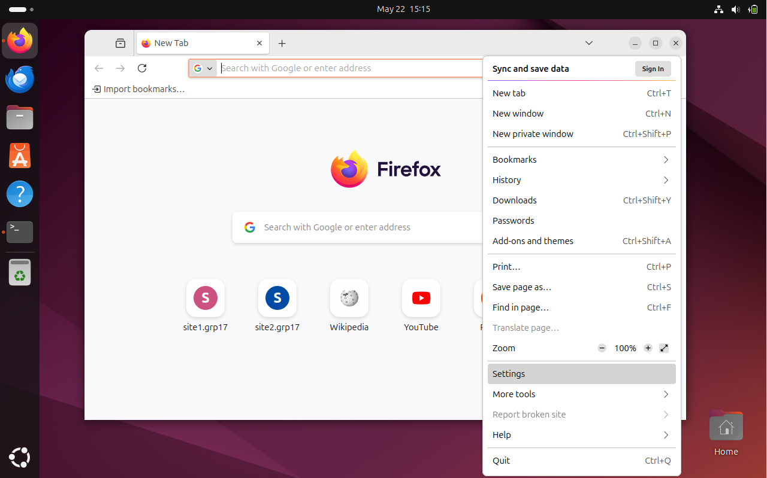

**2**



**Step 5:**

* We click to **Private & Security** and scroll down to the **Certificates** part.
* Click the **View Certificates** button.

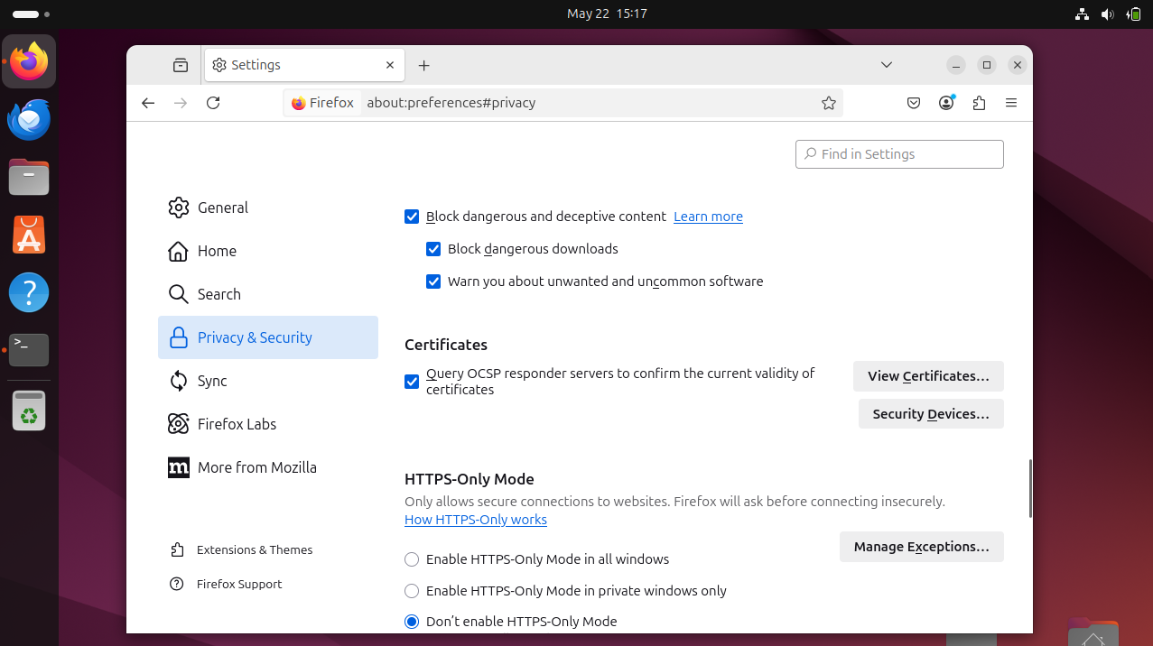

**2**

**1**



**Step 6:**

* Next, we click to **Authorities.** Select the **Import** button to import the certificate to **FireFox.**

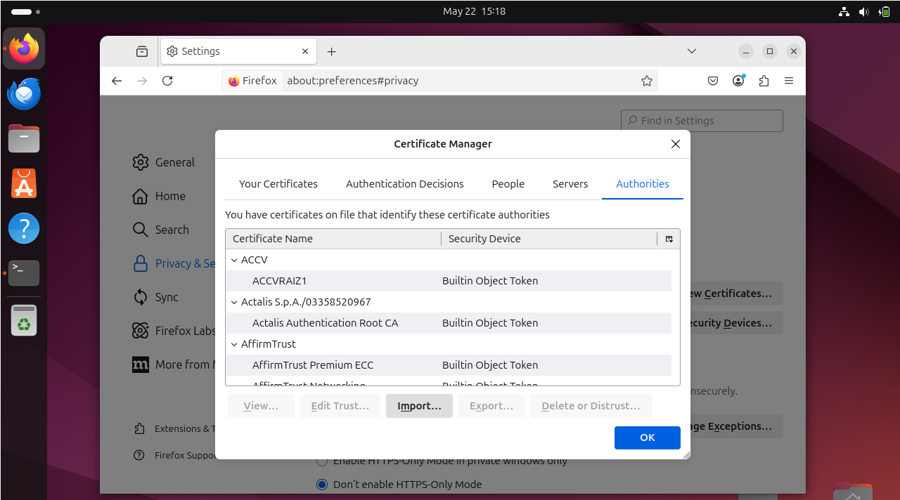



**2**

**1**



**Step 7:**

* We go the directory and our certificate that we copied just now from Rocky Server.
* **Selec**t it and press the **select button.**

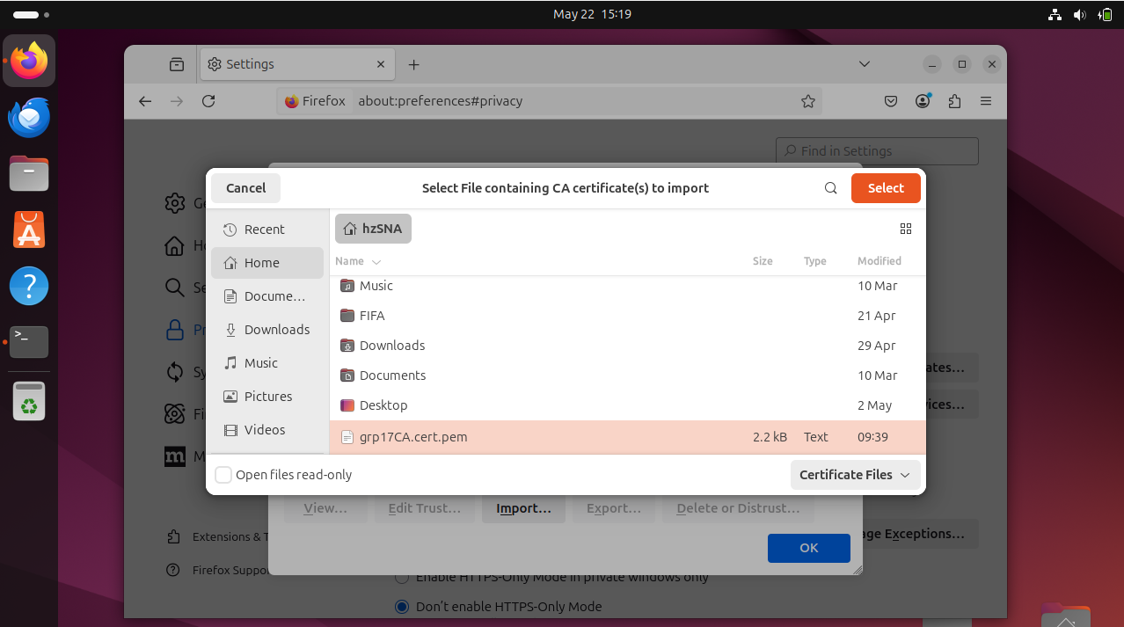

**1**

**2**



**Step 8:**

* It will prompt out a box after clicked the select button.
* We need to check the checkbox of **Trust this CA to identify websites.**
* And press **OK** button.

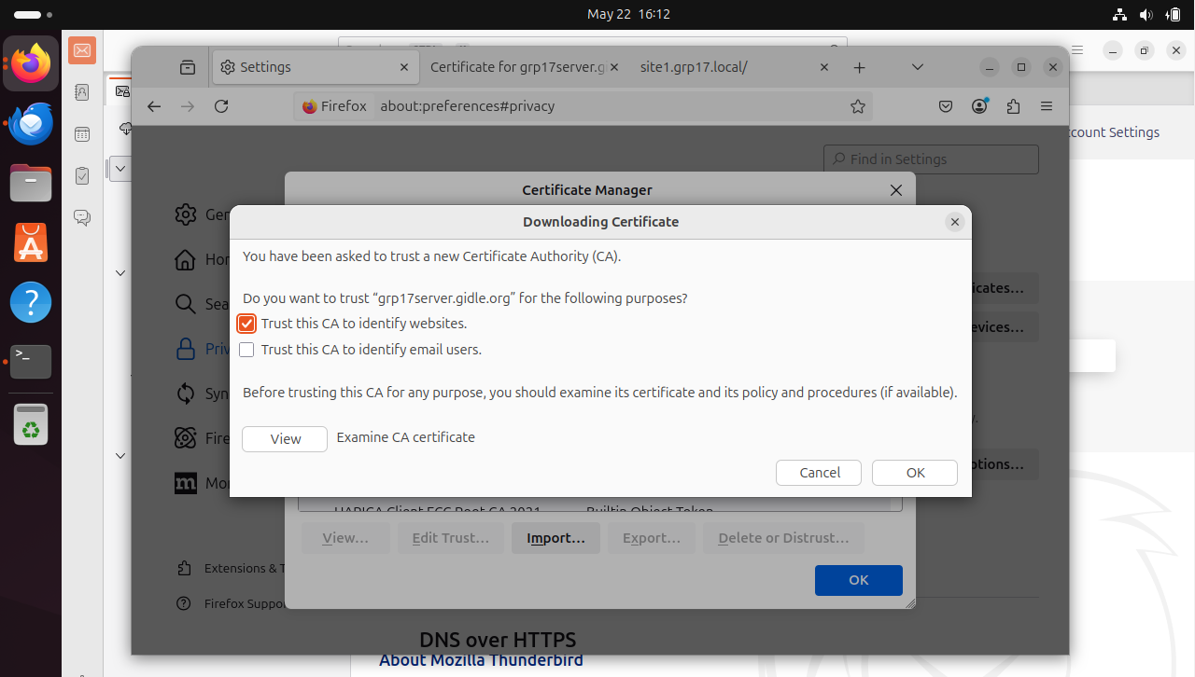

**3**

**2**

**1**



**Step 9:**

* Now, you will see the cert that we import is inside the authorities lists.
* Press **OK button** proceed to next step.

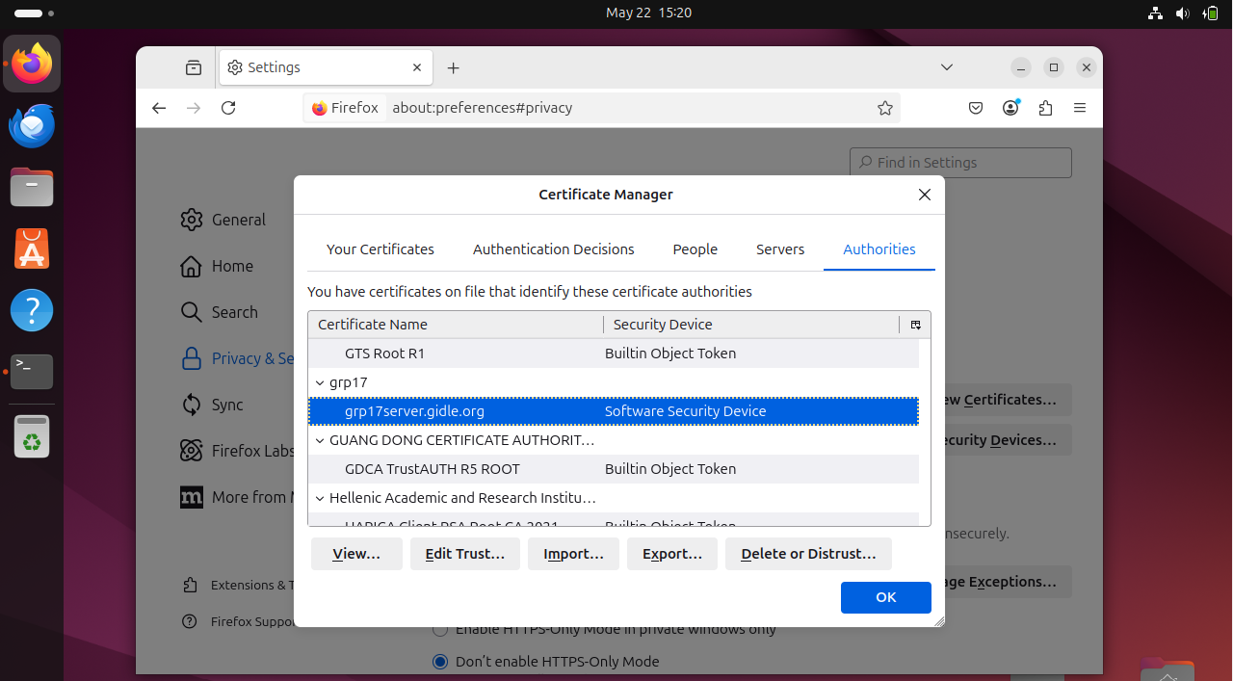



**Step 10:**

* Otherwise, we can close the cert and click **View button** to view the certificate of **grp17server.gidle.org**.
* Below is the view of certificate.

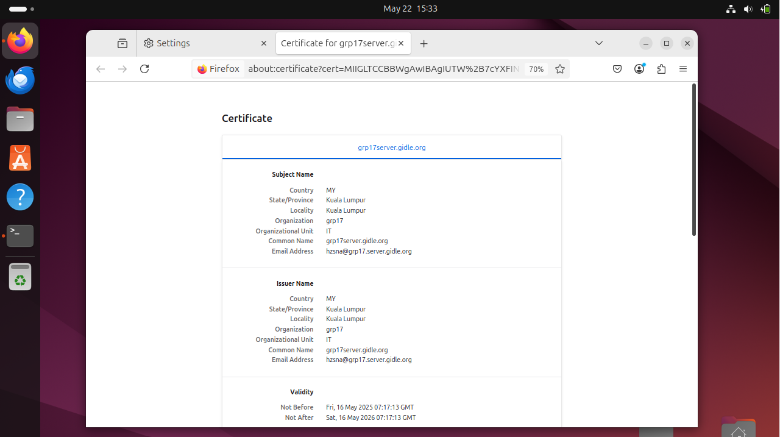



### 5.2.7 Enable HTTPS Support in Apache

**Step 1:**

* We go back to Rocky server and do some configuration for HTTPS.
* We need to open and modify the **httpd.conf** file.
* sudo nano /etc/httpd/conf/httpd.conf

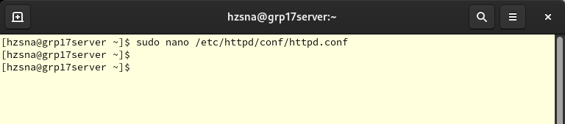



**Step 2:**

* Next, we add the lines below to ensure that our **port 443 (HTTPS)** is listening.
* Listen 443
* After added, **Save** **(Ctrl + S)** and **Exit (Ctrl + X)** the file.

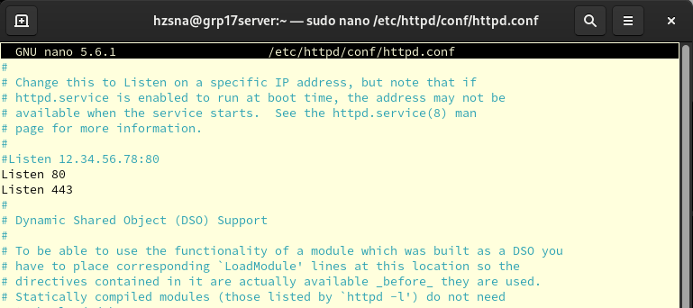



**Step 3:**

* Also, we can check whether our **port 443** is listening by using below command.
* sudo ss -tuln | grep :443
* Make sure that the port is under **LISTEN** status.

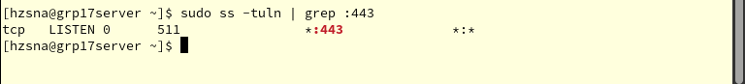



**Step 4:**

* Since we did some configuration above, we need to **restart** our httpd.
* sudo systemctl restart httpd
* We see the status of httpd and ensure it is **active (running)**.
* sudo systemctl status httpd

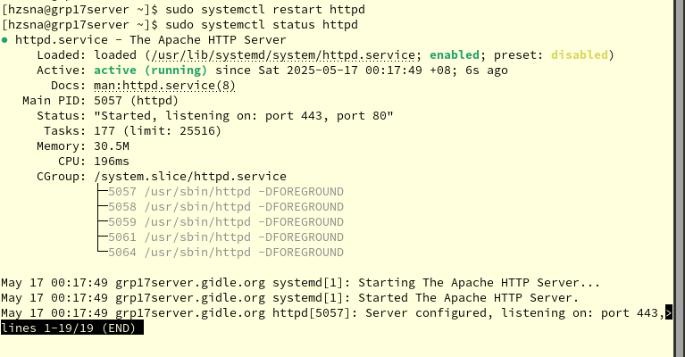



## 5.3 Testing HTTPS between Client and Server

**Step 1:**

* We go to Ubuntu Client and test **HTTPS** for the websites.
* Open the **FireFox** and type the website in the search box **with HTTPS**.
* https://site1.grp17.local/

**1**

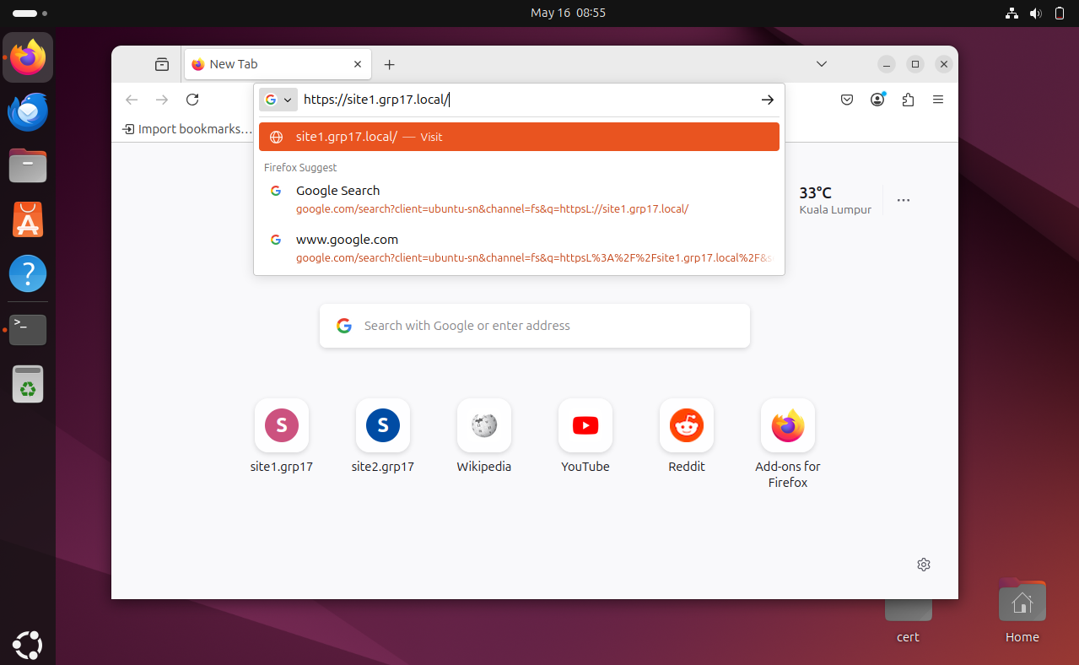

**2**



* After press enter, it will show the content of this website.
* We will see a **Lock icon** beside our website name. It means our website is secure.

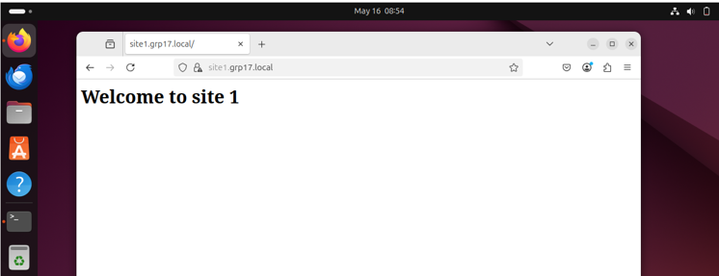

The site is SECURE for now



**Step 2:**

* We do the same steps for **site 2.**
* https://site1.grp17.local/
* After press enter, it will show the content of this website.
* We will see a **Lock icon** beside our website name. It means our website is secure.

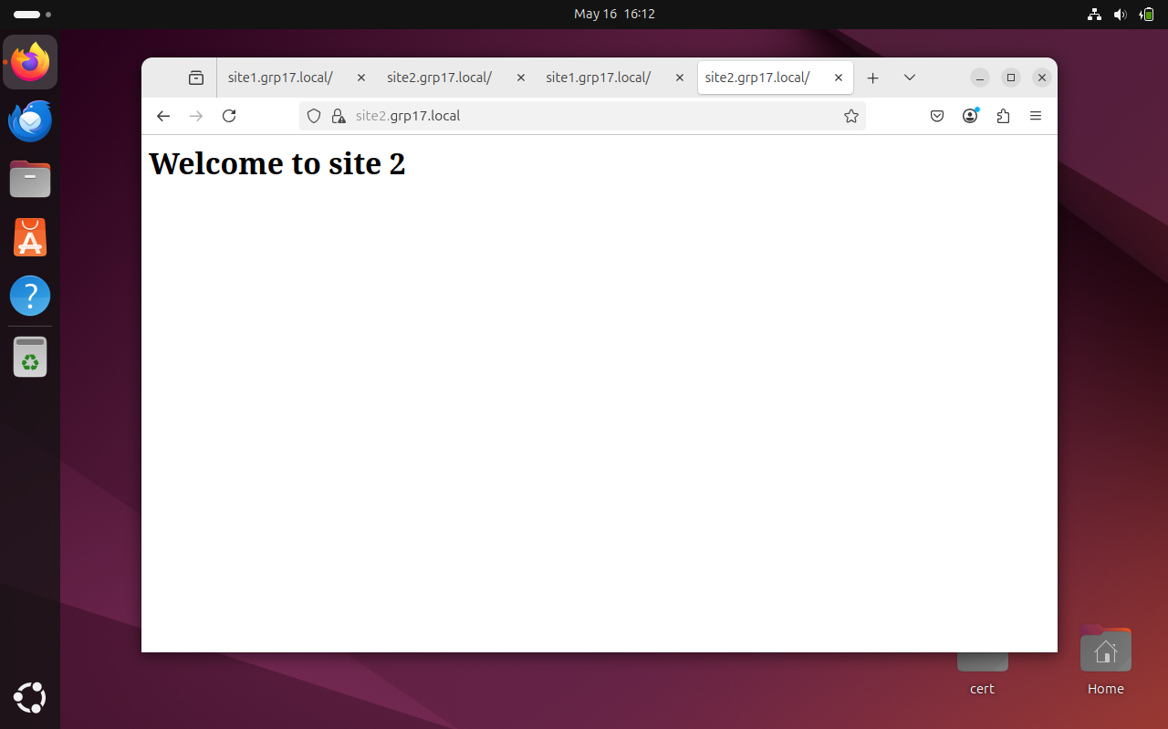

The site is SECURE for now



## 5.4 Secure email between Client and Server

### 5.4.1 Configure Postfix

**Step 1:**

* For using the new CA that we created in **Thunderbird**, which is **trusted CA – self-signed certificate,** we need to configuration our **Postfix.**
* We open the **main.cf** configuration file for **Postfix.**
* sudo nano /etc/postfix/main.cf

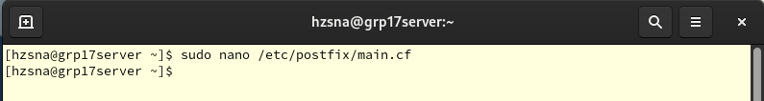



**Step 2:**

* We change the hostname to our **new hostname.**
* myhostname = grp17server.gidle.org

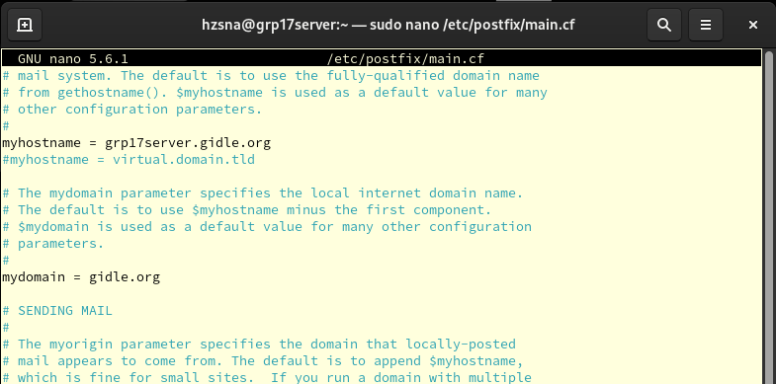



**Step 3:**

* Then, we need to locate and modify the following lines.
* Ensure these lines are present or uncommented. If they exist with different paths, make sure change according to the lines below.
* We will using the new **Certificate Authorities (CA)** **Certificate** in **Postfix main.cf.**
* smtpd_tls_cert_file=/etc/ssl/postdov/selfsigned.pem
* smtpd_tls_key_file=/etc/ssl/postdov/selfsigned.pem
* smtpd_tls_CAfile = /etc/pki/tls/grp17CA/grp17CA.cert.pem

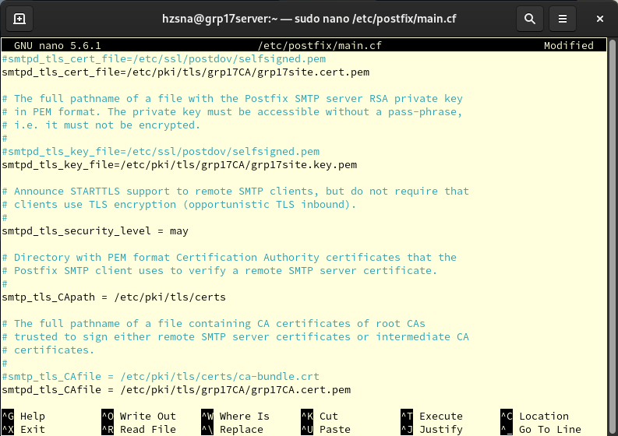



### 5.4.2 Configure Dovecot

**Step 1:**

* After done in Postfix, we need to do **some configuration** for **Dovecot.**
* We open the **10-ssl.conf** configuration file for **Dovecot.**
* sudo nano /etc/postfix/main.cf

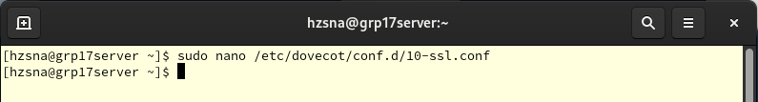



**Step 2:**

* We do the same things as we did when we configure Postfix.
* Ensure these lines are present or uncommented. If they exist with different paths, make sure change according to the lines below.
* We locate the new **CA Cert** in Dovecot SSL configuration file.
* ssl_cert = </etc/pki/tls/grp17CA/grp17site.cert.pem
* ssl_key = </etc/pki/tls/grp17CA/grp17site.key.pem
* ssl_ca = </etc/pki/tls/grp17CA/grp17CA.cert.pem

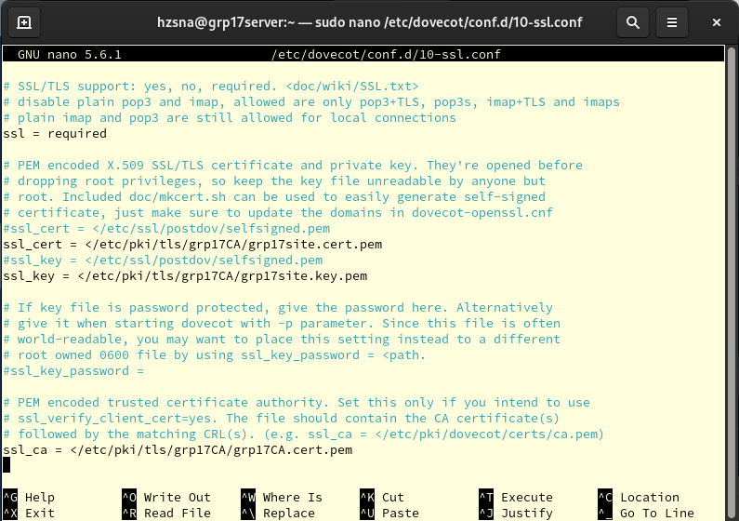



**Step 3:**

* After done all the configuration, we **restart** both **Postfix and Dovecot** due to the changes.
* sudo systemctl restart postfix
* sudo systemctl restart dovecot
* Next, we check the **status** of our **Postfix and Dovecot.**
* Makes the services is **active (running).**
* sudo systemctl status postfix

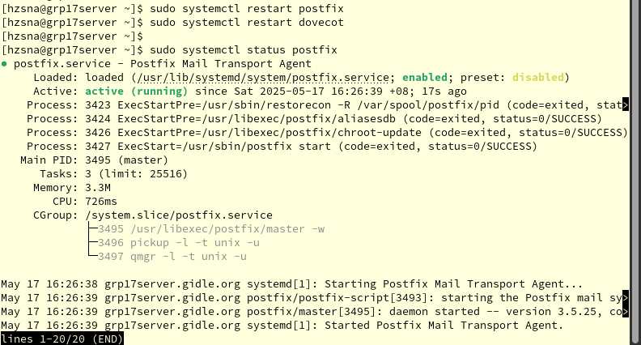



* sudo systemctl status dovecot

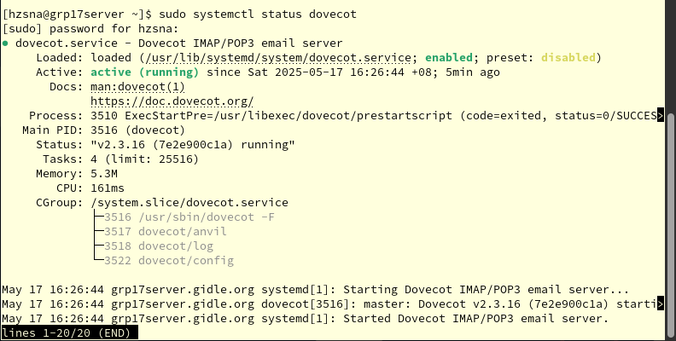



### 5.4.3 Testing secure email between Client and Server

**Step 1:**

* We open the **Thunderbird Mail** in Ubuntu.

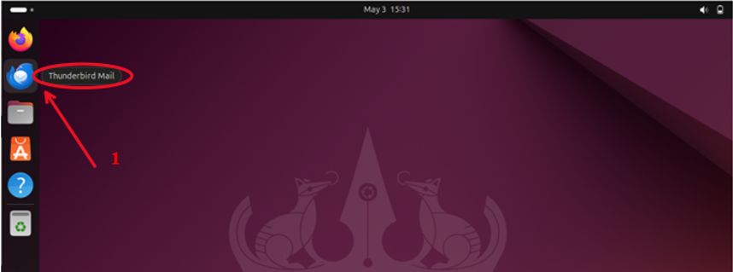

**Step 2:**

* After Thunderbird is opened, we create an existing user in Rocky server.
* We use the new hostname that changed **(grp17server.gidle.org).**
* Set **Email address:** with format: **fullname@hostname**
* Make sure the **Password** is entered correctly.
* After done, we click **Configure manually.**

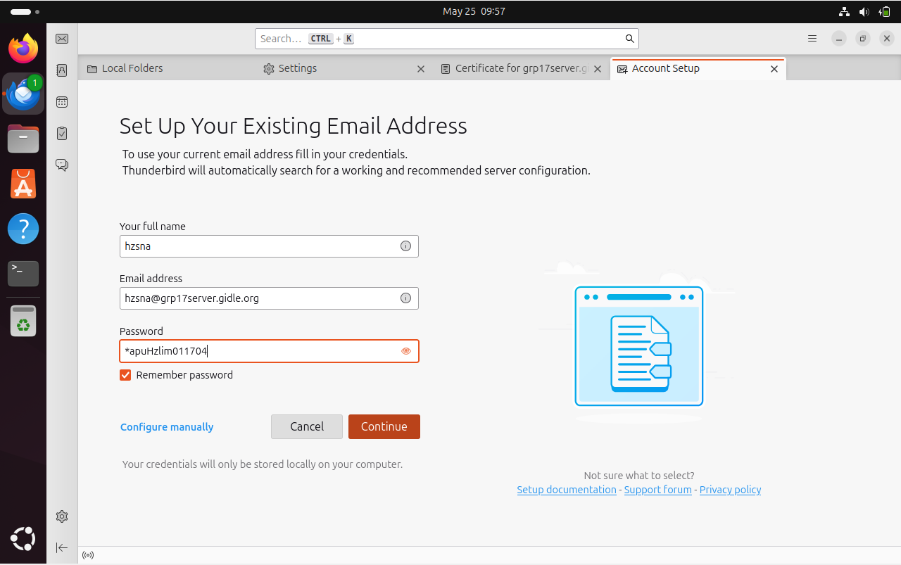

**4**

**2**

**3**

**1**



**Step 3:**

* We check whether our configure is correct that we did before in our individual assignment.
* It will prompt out a Green Colour Box mentioned that the following settings were found by probing the given server.
* Then we click the **Done** button below.

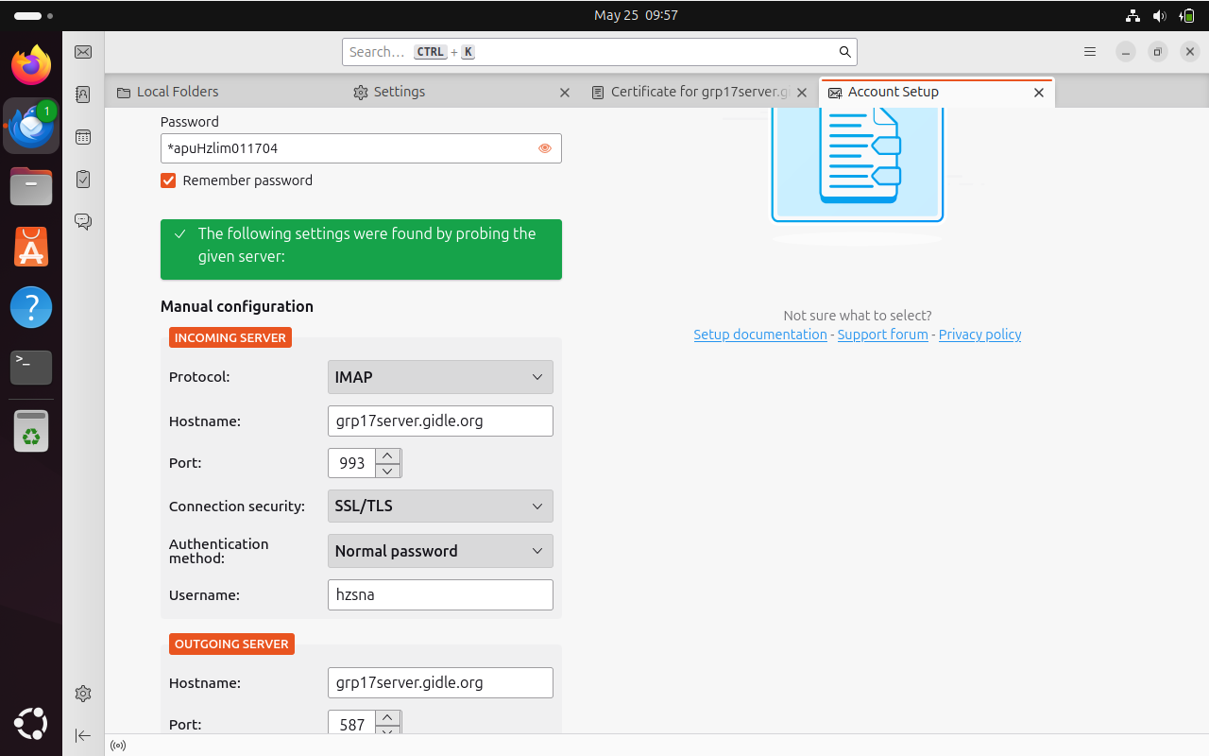

The configuration is all same as we setup previously in individual Assignment.



**Step 4:**

* In this step, it will prompt out the window for **Add Security Exception**.
* Thunderbird indicating a security exception
* Since we have used the new CA that trusted – **self-signed CA,** it will mention that **Valid Certificate** when we click **Get Certificate.**
* It will prompt out the certificate for **grp17server.gidle.org** by clicking the ***View***button.

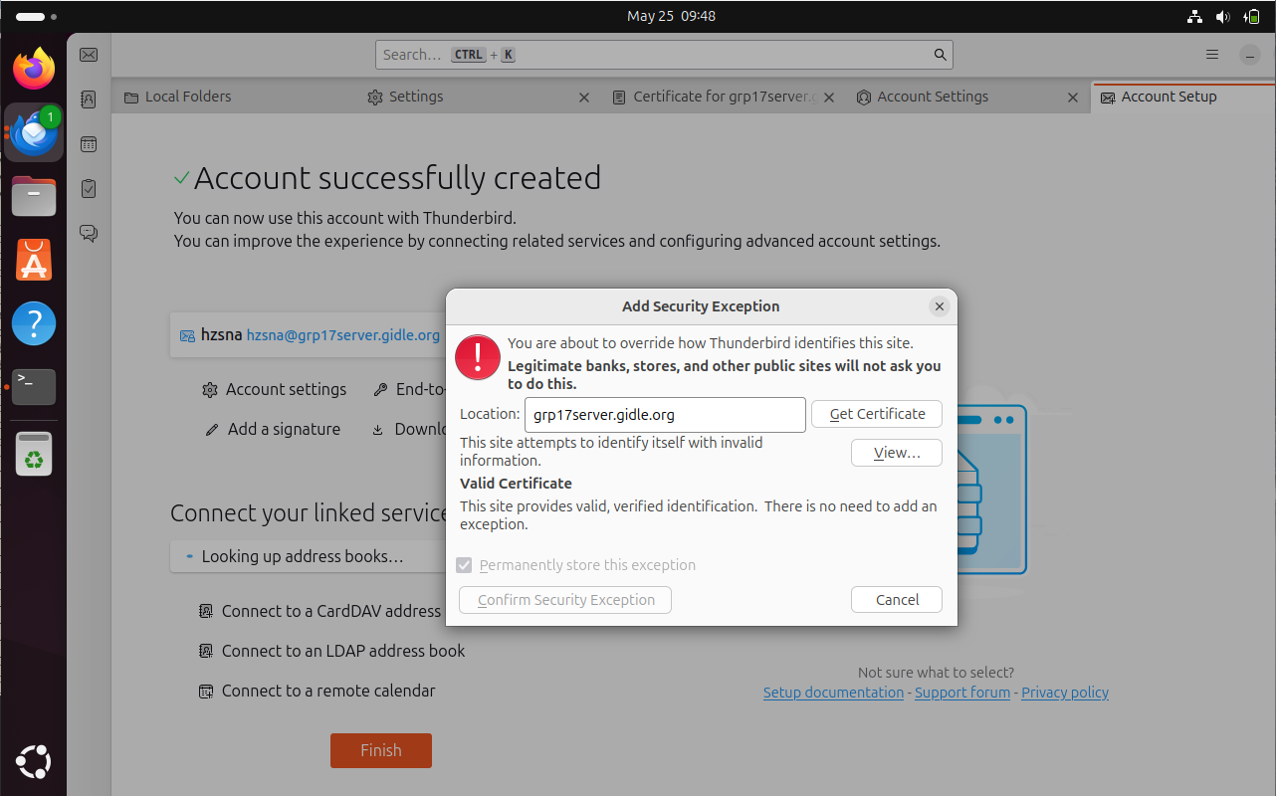

**2**



**1**



**Step 5:**

* Next, we click cancel. By right, it will prompt out another same box.
* Even though the system might trust your CA, Thunderbird itself might have an additional trust mechanism, or for security reasons during the initial connection.
* Here, we just need to click the **Confirm Security Exception** button by checking the **Permanently store this exception.**

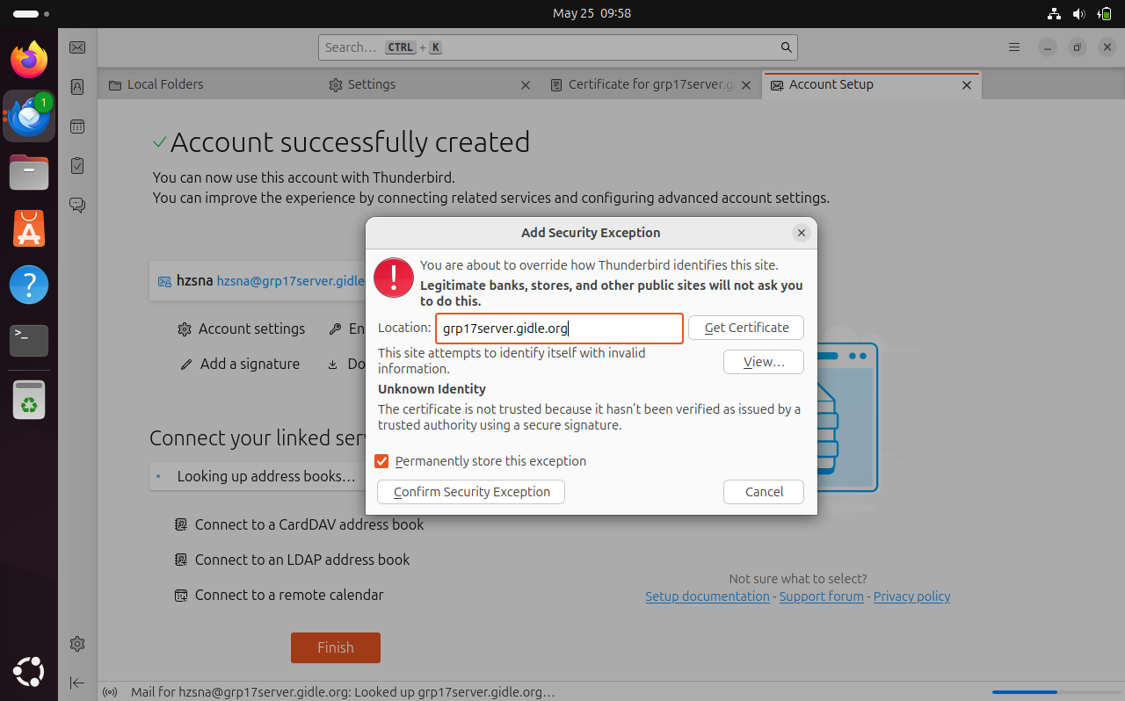



**1**



**Step 6:**

* After login to the Thunderbird main page, we will create another new user account.
* We do the same thing as we done for the first user – hzsna.
* We use the new hostname that changed **(grp17server.gidle.org).**
* Set **Email address:** with format: **fullname@hostname**
* Make sure the **Password** is entered correctly.
* After done, we click **Continue** button below and you will see the configuration is available.

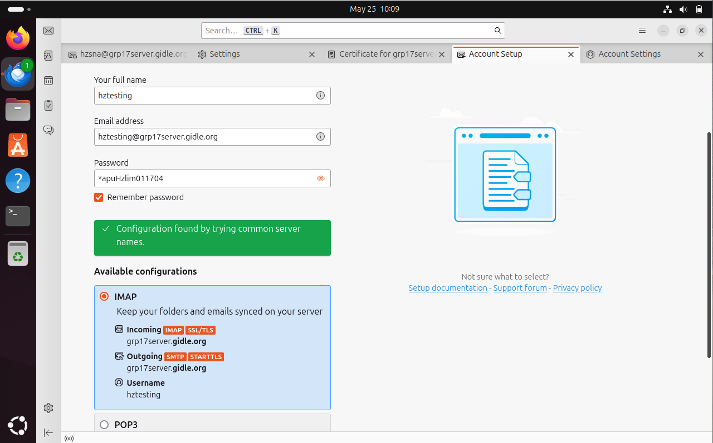



**3**

**2**

**1**



**4**



**Step 7:**

* We will see two account that we created in the Thunderbird main page.
* Now, we test to send some message between these two accounts.
* Click the New Message box for testing send email from **hzsna@grp17server.gidle.org** to **hztesting@grp17server.gidle.org**

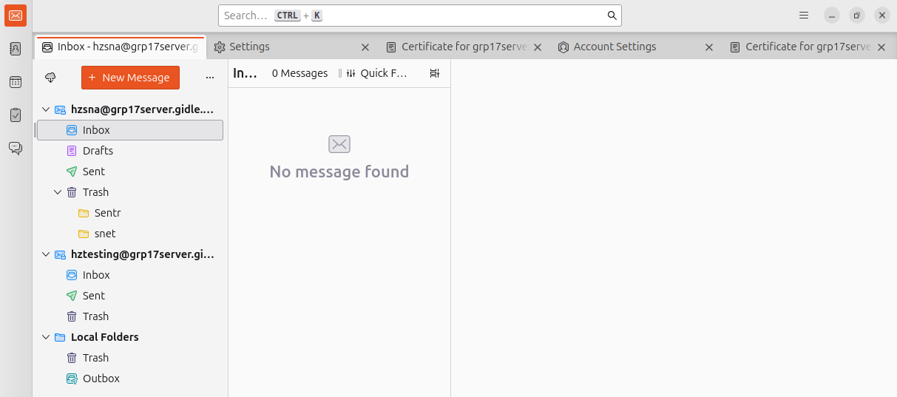

**1**



**Step 8:**

* We send the message **To: hztesting@grp17server.gidle.org.**
* Setting the **Subject: testing** and write some content in the text box.
* Click the **Send** button.

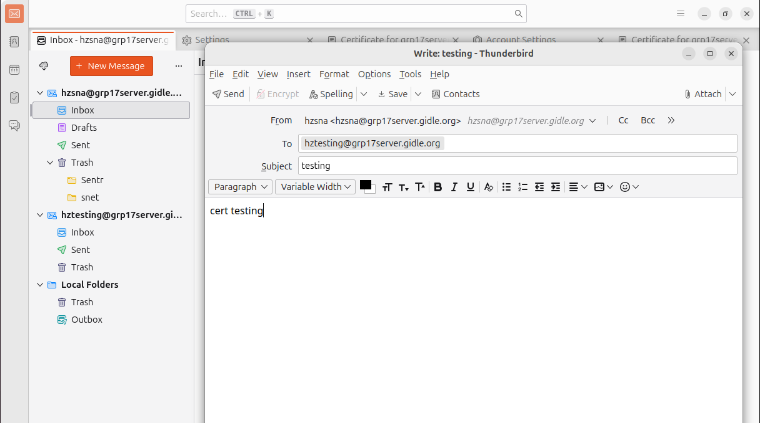

**2**



**3**

**1**



**Step 9:**

* Next, we will receive the email that we sent from **hzsna@grp17server.gidle.org** inside the inbox.
* By safety purpose, we use another account **hztesting@grp17server.gidle.org** send a new email again.

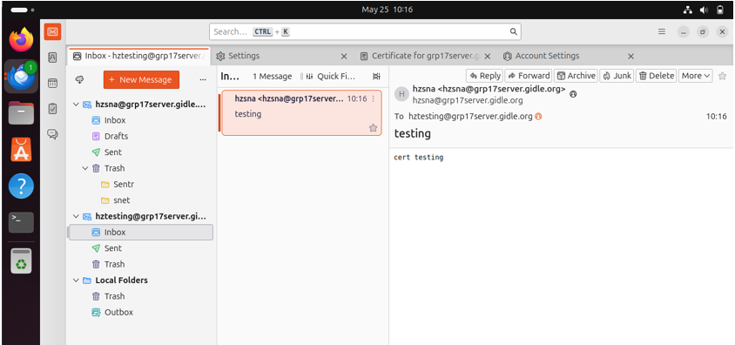

Here is the email that we received.

**3**

**2**

**1**



**Step 10:**

* We send the message **To: hzsna@grp17server.gidle.org.**
* Setting the **Subject: testing back** and write some content in the text box.
* Click the **Send** button.

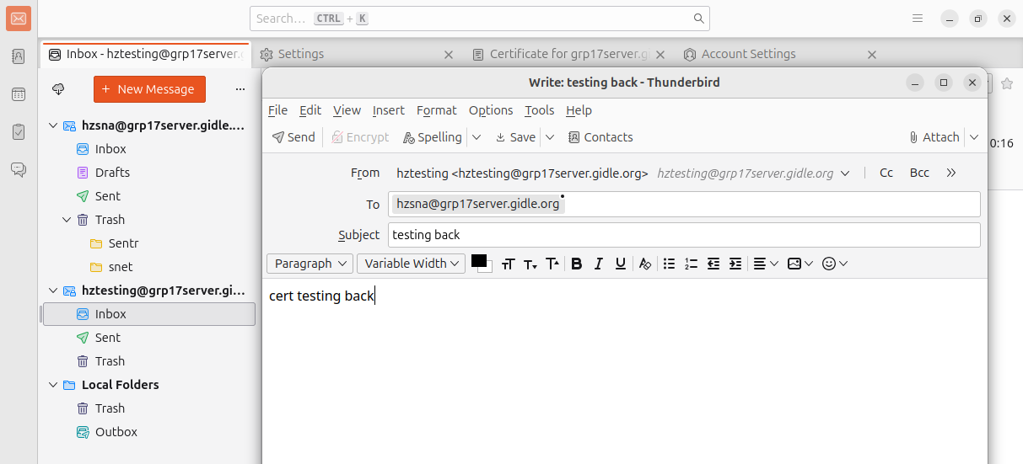

**3**

**2**

**1**



**Step 11:**

* Lastly, we will receive the email that we sent from **hztesting@grp17server.gidle.org** inside the inbox.
* After we receive the email, we done add the configuration and testing correctly.

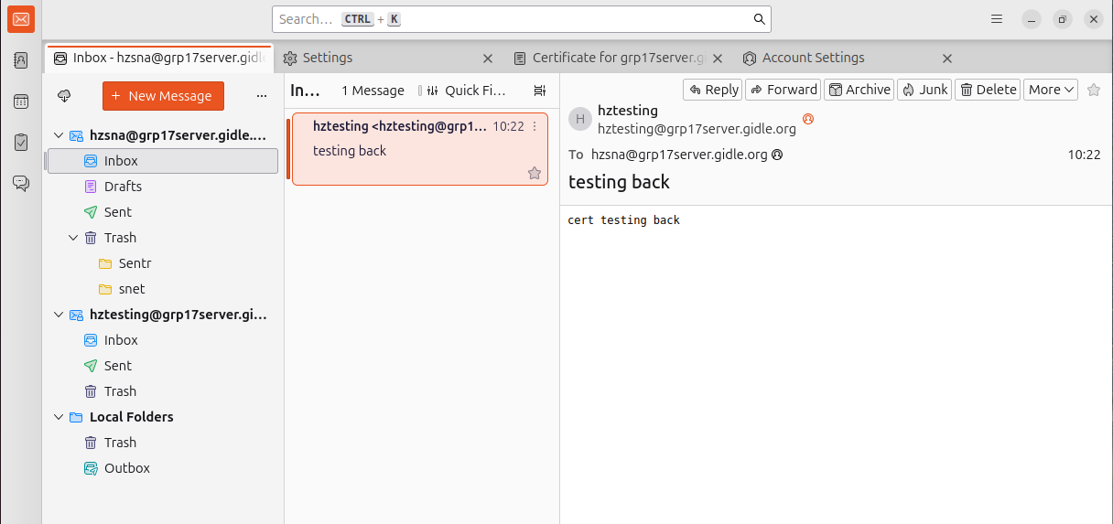



Here is the email that we received.

**2**



**1**



### 5.4.4 New Certificate for Thunderbird

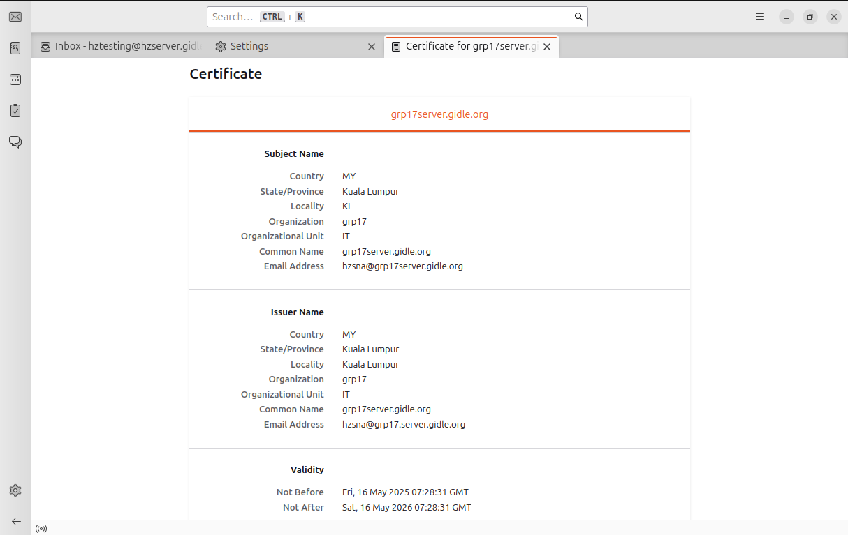



# 6.0 Additional Service – Samba

## 6.1 Configure Samba

**Step 1:**

* Firstly, we install the **Samba**. It allows to share files over a network using the **SMB/CIFS** protocol.
* sudo dnf install samba samba-common samba-client -y

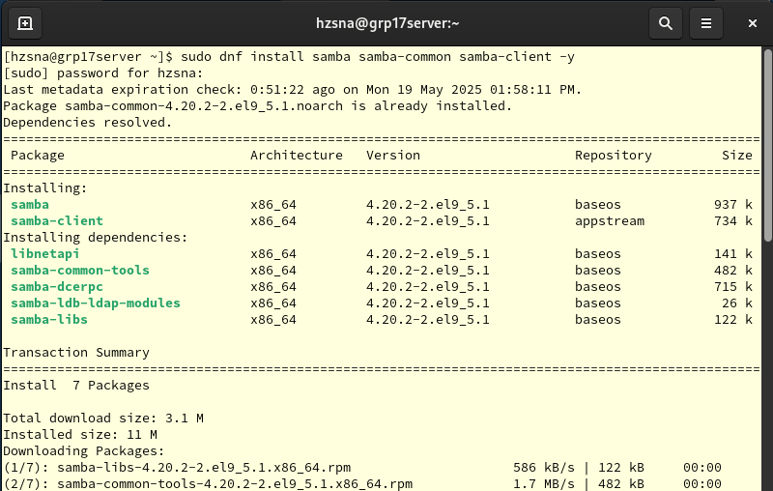



**Explanation of the above command:**

* **samba-common:** Installs shared configuration files and tools needed by all Samba components.
* **Samba-client:**  Installs the client tools, like **smbclient**, so our system can access other Samaba shares.

**Step 2:**

* Next, we need to setting up a pubic, fully accessible shared folder for use with Samaba.
* sudo mkdir -p /samba/shared
* sudo chown -R nobody:nobody /samba/shared
* sudo chmod -R 0777 /samba/shared

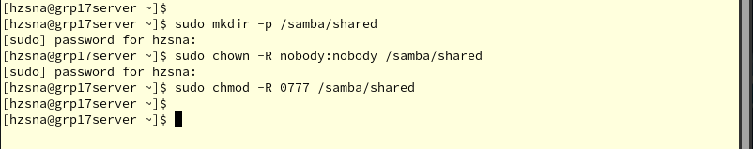



**Explanation of the above command:**

* **sudo mkdir -p /samba/shared:** It creates the directory /samba/shared.
* **sudo chown -R nobody:nobody /samba/shared:** This option tells to change the owner for all the folders to nobody (user:group). The nobody user is commonly used for guest access, means no login needed.
* **sudo chmod -R 0777 /samba/shared:** Gives full permission (read/write/execute) to everyone, which is owner, group and others.

**Step 3:**

* We are now **backing up** the existing Samba configand **editing the Samba configuration file** using following command.
* We copy the current **Samba config file** to a backup **smb.conf.bak.**
* sudo cp /etc/samba/smb.conf /etc/samba/smb.conf.bak
* After done the backup, we open the **Samba config file** and add or modify **share definitions** and settings.
* sudo nano /etc/samba/smb.conf

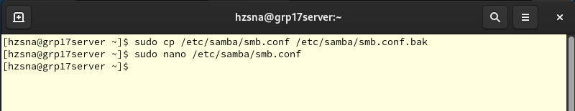



**Step 4:**



* Inside the **smb.conf,** scroll to the bottom and add the following lines below.
* [Shared]

path = /samba/shared

browsable = yes

writable = yes

guest ok = yes

read only = no

force user = nobody

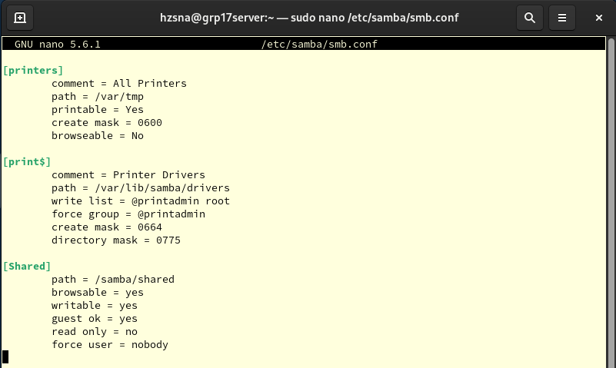



**Step 5:**

* Now, we are **starting** and **enabling** the Samba services. Ensuring it **automatically runs at startup**, so our shared folder will always be available.
* sudo systemctl enable --now smb nmb

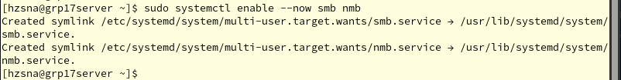



**Explanation of the above command:**

* **--now:** Immediately starts the service right now without needing a reboot.
* **smb:** Starts the SMB (Samba Server) service. It handles file sharing.
* **nmb:** Starts the NMB (NetBIOS Name Service). It helps Windows systems discover your Samba server on the local network.

**Step 6:**

* In this step, we allow Samba service through the system firewall, so other devices can connect to the Samba share.
* sudo firewall-cmd --permanent --add-service=samba
* sudo firewall-cmd --reload

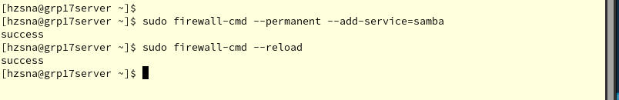



**Step 7:**

* Here, we make sure the Samba service is running now and always starts automatically using following command.
* sudo systemctl start smb

sudo systemctl enable smb

* Also, make sure the status is **active (running).**
* sudo systemctl status smb

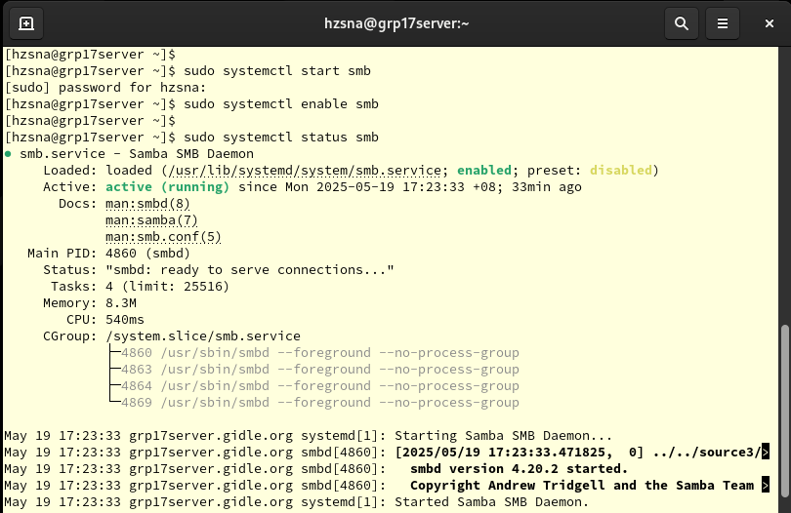



**Step 8:**

* This is the important step. We label the custom shared folder so **SELinux will allow Samba to use it.**
* sudo semanage fcontext -a -t samba_share_t “/samba/shared(/.*)?”
* sudo restorecon -Rv /samba/shared





**Explanation of the above command:**

* **semanage fcontext -a:** Adds a file context rule for SELinux.
* **-t samba_share_t:** It assigns the samba_share_t type, which tells SELinux that this directory can be accessed by Samba.
* **“/samba/shared(/.*)?”:** It applies to /samba/shared and everything inside it (/.*).
* **restorecon:**  Applies the SELinux lables that defined.
* **-R:** Recursive (applies to all files).
* **-V:** Verbose output (shows what it is doing).

## 6.2 Test Service on Ubuntu

**Step 1:**

* We need to install the **cifs-utils tools** to mount and access Samba/CIFS shared folders on Ubuntu.
* sudo apt install cifs-utils -y

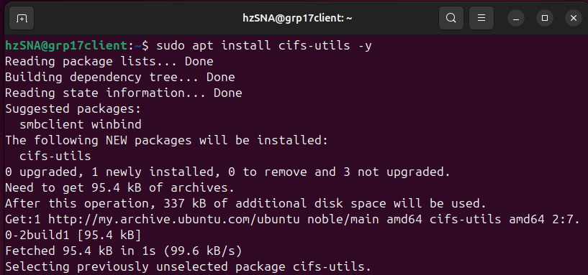



**Step 2:**

* Now, we use the following command to mount a shared folder from a remote Samba server onto local Ubuntu system.
* sudo mount -t cifs //192.168.200.4/Shared /mnt -o guest,uid=1000,gid=1000
* Next, we check whether the mount was successful and confirms that the shared folder is mounted.
* mount | grep cifs

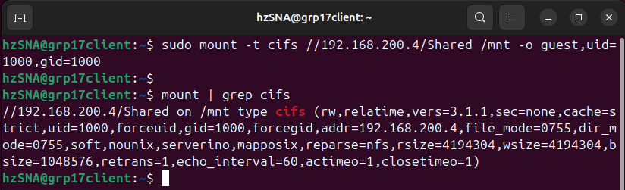



**Explanation of the above command:**

* **mount:** The command used to mount filesystems.
* **-t cifs:**  Specifies the type of filesystem to mount. CIFS is used for accessing shared folders over a network.
* **//192.168.200.4/Shared:** The network location of the shared folder.
* **/mnt:** The local directory where the shared folder will be mounted.
* **-o guest:**  Connects as a guest user, which means no username or password required.
* **uid=1000,gid=1000:** Sets the ownership of the moubted files to local user with user ID and group ID of 1000.

**Step 3:**

* After we mount the shared folder, we confirm that the share is visible and has available space using following command.
* df -h | grep /mnt





**Explanation of the above command:**

* **df:** Stands for the disk filesystem. It shows how much space is used and available on all mounted filesystems.
* **-h:** It stand for human-readable, means show sized in KB, MB or GB.

**Step 4:**

* Here, we want to test that we can write files to the mounted share.
* We use the following command to creates a simple text **finaltext.txt**, with the content **“This is a final test”** on Samba share.
* If this file gets created and we can read it back, it confirms that the Samba CIFS mount is working properly with write permissions.
* echo “This is a final test” | sudo tee /mnt/finaltest.txt





**Step 5:**

* In this step, we check the files on our mount point. It will list out the file that existing.
* Make sure the **finaltest.txt** that we created is existing in the list.
* ls /mnt
* We check whether the **finaltest.txt** file contains the expected text.
* If both commands above is work fine, the **CIFS/Samba** mount is working properly for **read/write** operations.
* cat /mnt/finaltest.txt



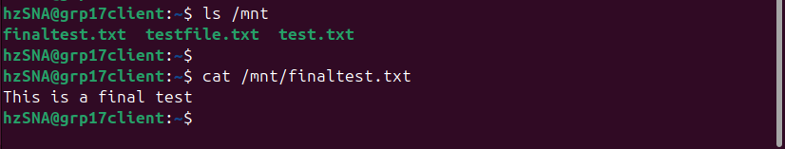



**Step 6:**

* Lastly, we need do this from the Rocky server, checking the shared Samba directory **/samba/shared** using below command.
* We will see the **finaltest.txt** that created on Ubuntu client.
* If yes, our mounting and testing are successful.
* ls -l /samba/shared

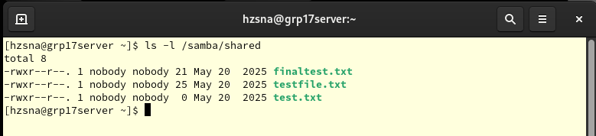

The finaltest.txt file that we created will appear in Rocky Server.



# 7.0 Conclusion

By completing this assignment, we were able to build a Rocky Linux server and an Ubuntu Linux client in VirtualBox. After completing the network settings, file sharing, web services, and data security settings, we were able to simulate the operation processes in a small to medium-sized organization.

We assigned the server a permanent IP address and full name, and installed NFS and Apache. With these actions, we learned to manage the server effectively. We knew everything was working fine when we found that the Ubuntu client was able to handle the shared directories and websites on the Rocky server. Our connection was more secure thanks to an SSL certificate from a custom Certificate Authority (CA), which also enabled the HTTPS protocol, allowing us to access secure web pages.

We also add an extra service that we never learned about in previous lab tutorials. So, we had to learn by ourselves and apply our knowledge to related subjects. We must be relied on SAMBA to make file sharing possible between Linux and Windows operating systems. We gained hands-on experience with operating across platforms and controlling access to files and learned about how companies handle file services in mixed operating system networks. This project helped us develop confidence and gain useful skills to run and secure Linux systems as needed.

# 8.0 Reference

1. *How to configure an Apache web server | Opensource.com*. (n.d.). Opensource.com. <https://opensource.com/article/18/2/apache-web-server-configuration>
2. Sah, J. (2024, September 20). *How to Install Apache Webserver on Rocky Linux 9*. Vultr.com; Vultr. <https://docs.vultr.com/how-to-install-apache-webserver-on-rocky-linux-9>
3. Jethva, H. (2022, April 14). *How to Generate Self-Signed SSL Certificates Rocky Linux 8*. Atlantic.net. <https://www.atlantic.net/dedicated-server-hosting/how-to-generate-self-signed-ssl-certificates-rocky-linux-8/>
4. Wale Soyinka. (2024). *Lab 8: Samba - Documentation*. Rockylinux.org. <https://docs.rockylinux.org/labs/networking/lab8-samba/>
5. Chauhan, N. (2024). *Samba Windows File Sharing - Documentation*. Rockylinux.org. <https://docs.rockylinux.org/guides/file_sharing/samba_file_share/>
6. *Install and Configure Samba*. (n.d.). Ubuntu. <https://ubuntu.com/tutorials/install-and-configure-samba#3-setting-up-samba>
7. Martin. (2017, May 8). *Changing Hostname and Fully Qualified Domain Name (FQDN) on Ubuntu*. Gridscale. <https://gridscale.io/en/community/tutorials/hostname-fqdn-ubuntu/>
8. *Network File System (NFS)*. (2025). Ubuntu Server. <https://documentation.ubuntu.com/server/how-to/networking/install-nfs/index.html>
9. Codex, A. C. (2024, January 26). *Configuring a Static IP Address on Rocky Linux 9*. Reintech.io; Reintech. <https://reintech.io/blog/configuring-static-ip-address-rocky-linux-9>
10. Boucheron, B. (2020, May 14). *How To Set Up an NFS Mount on Ubuntu 20.04*. DigitalOcean. <https://www.digitalocean.com/community/tutorials/how-to-set-up-an-nfs-mount-on-ubuntu-20-04>

# 9.0 Workload Matrix

